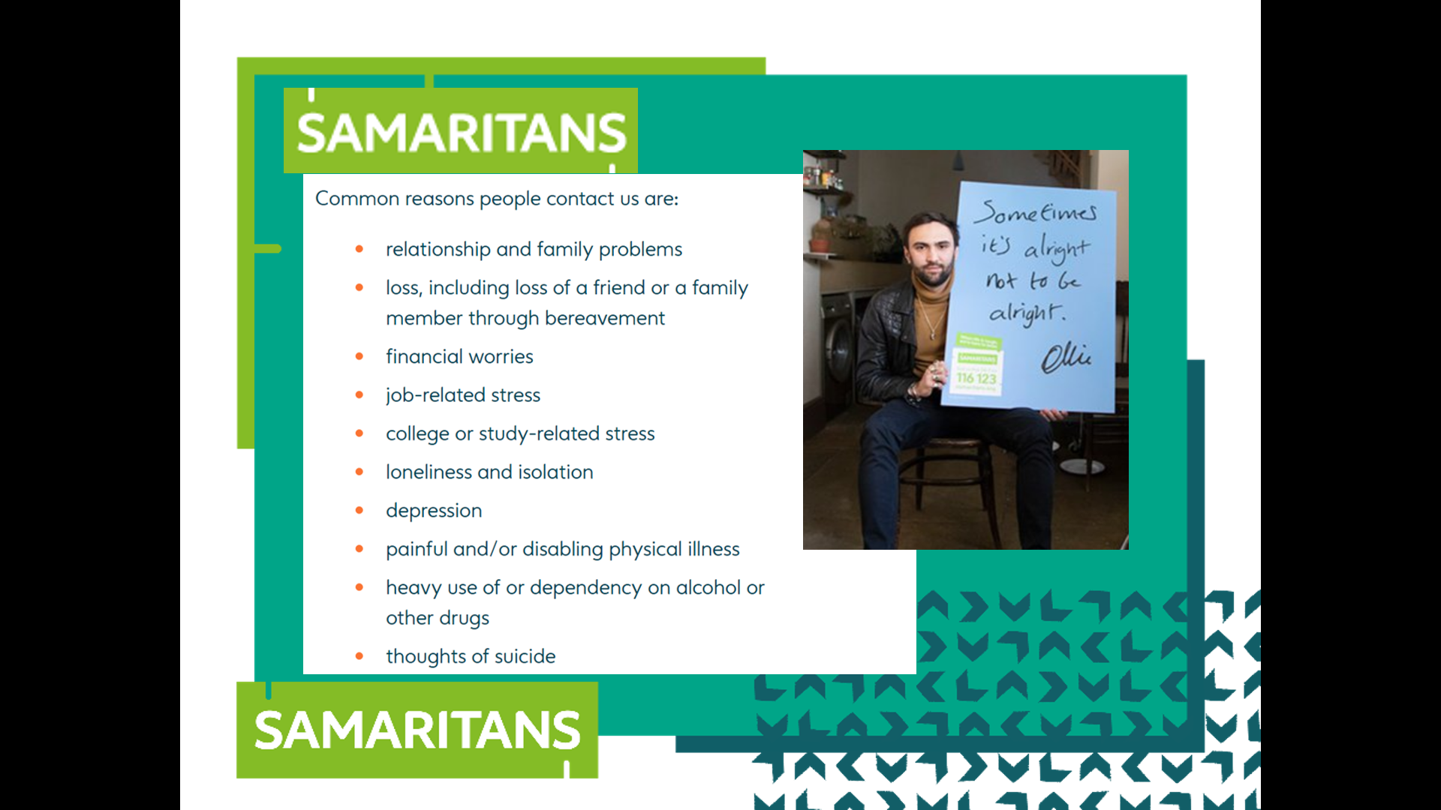
Display our list
Here is the list that appears on the Samaritans website. Compare the Samaritans list with the list from the class.

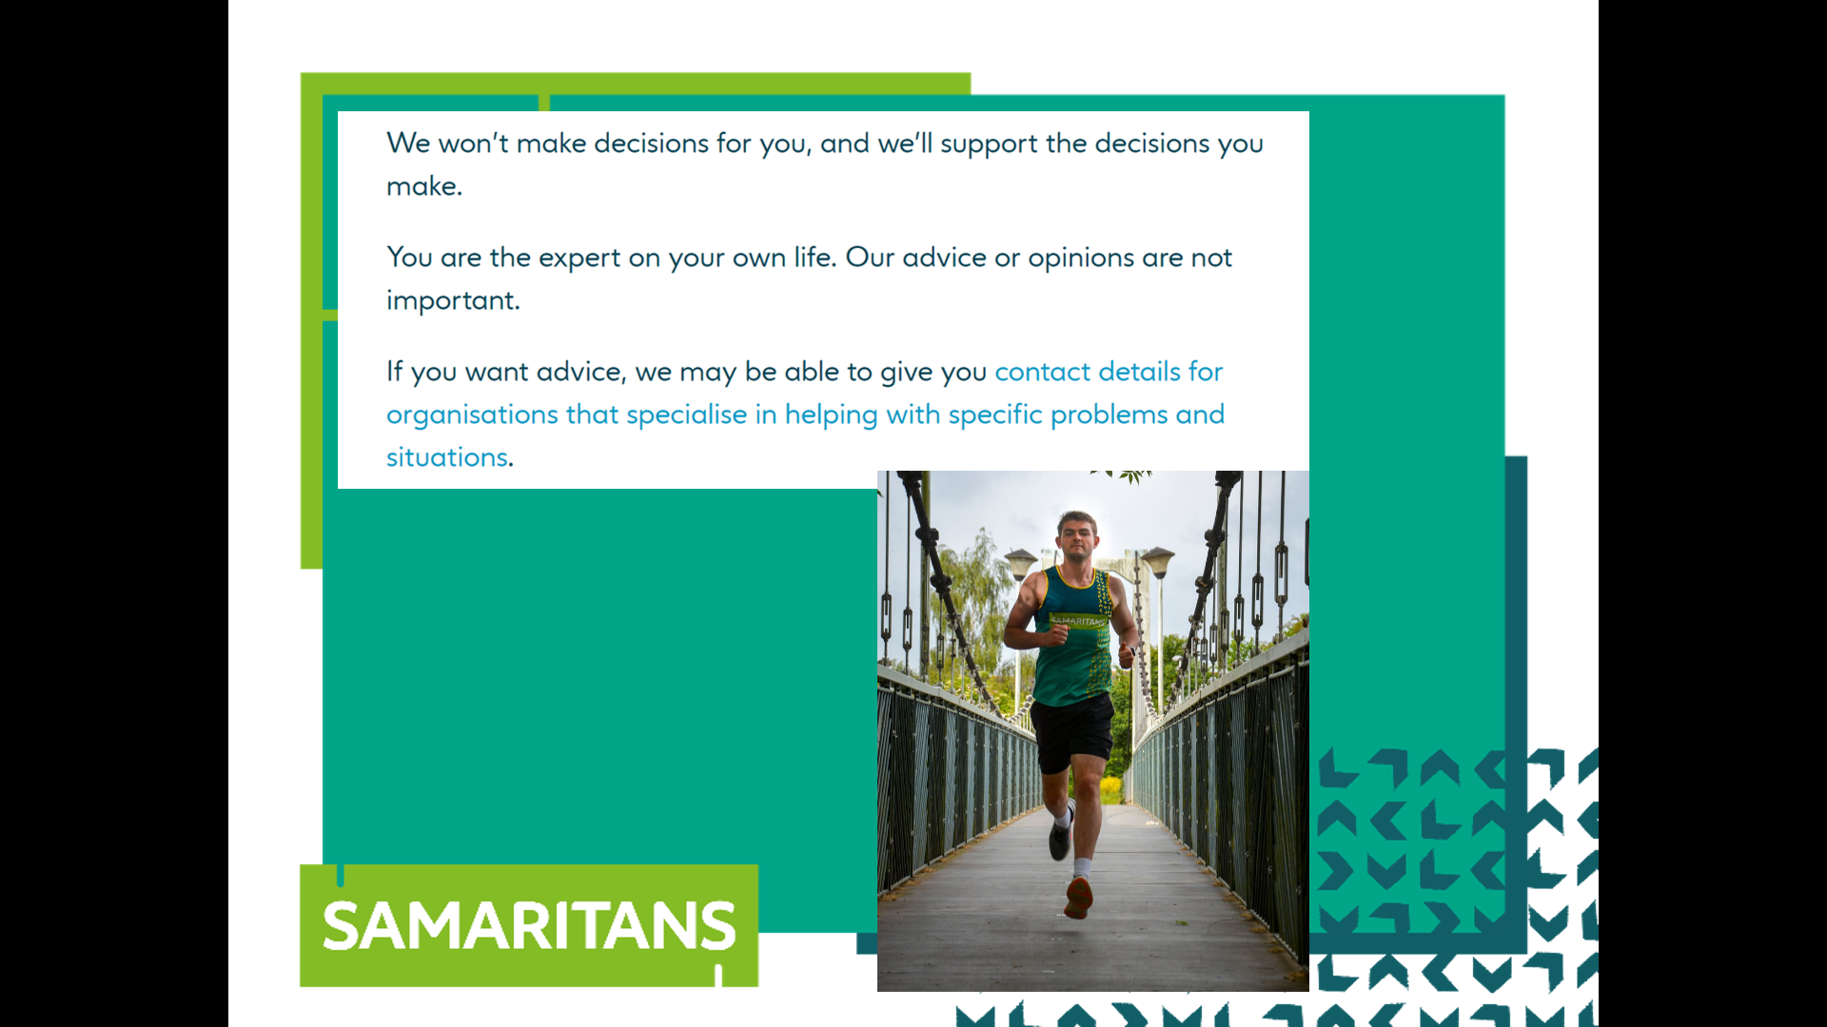
We don’t make decisions for you.

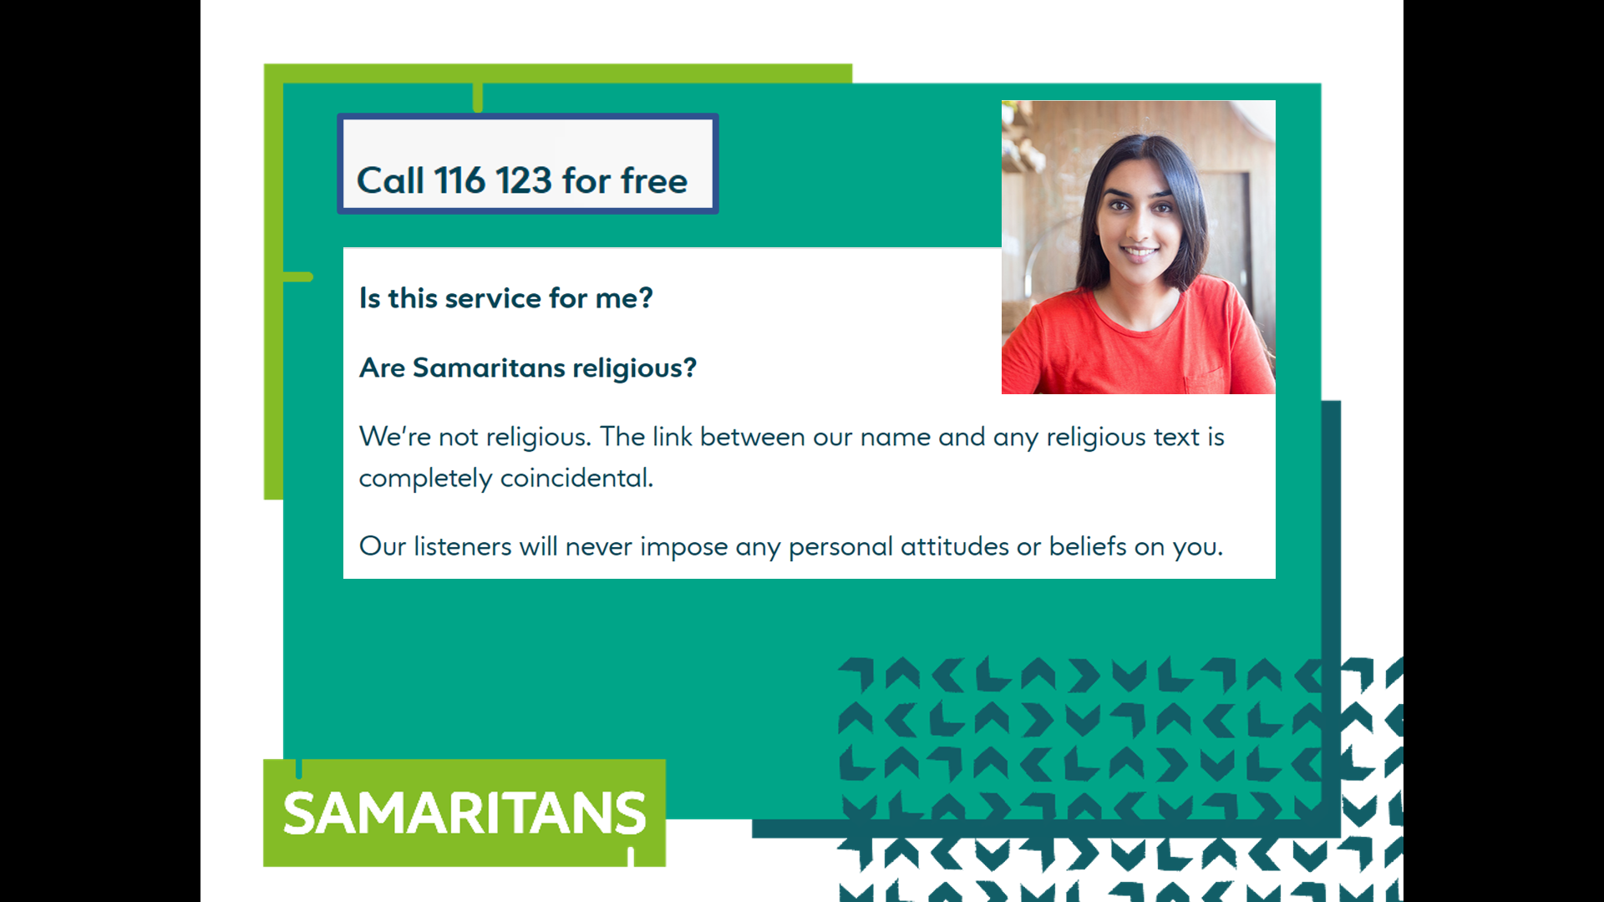
We are not religious and don’t make judgements.

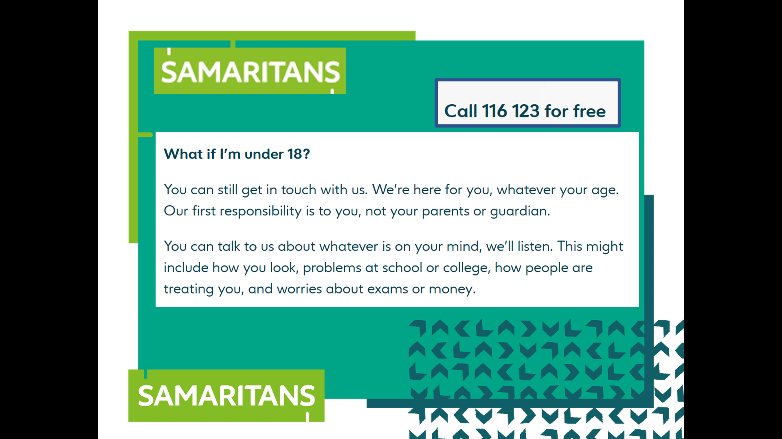
Our first responsibility is to our callers, whatever their age. We get calls from very young children and very old people.

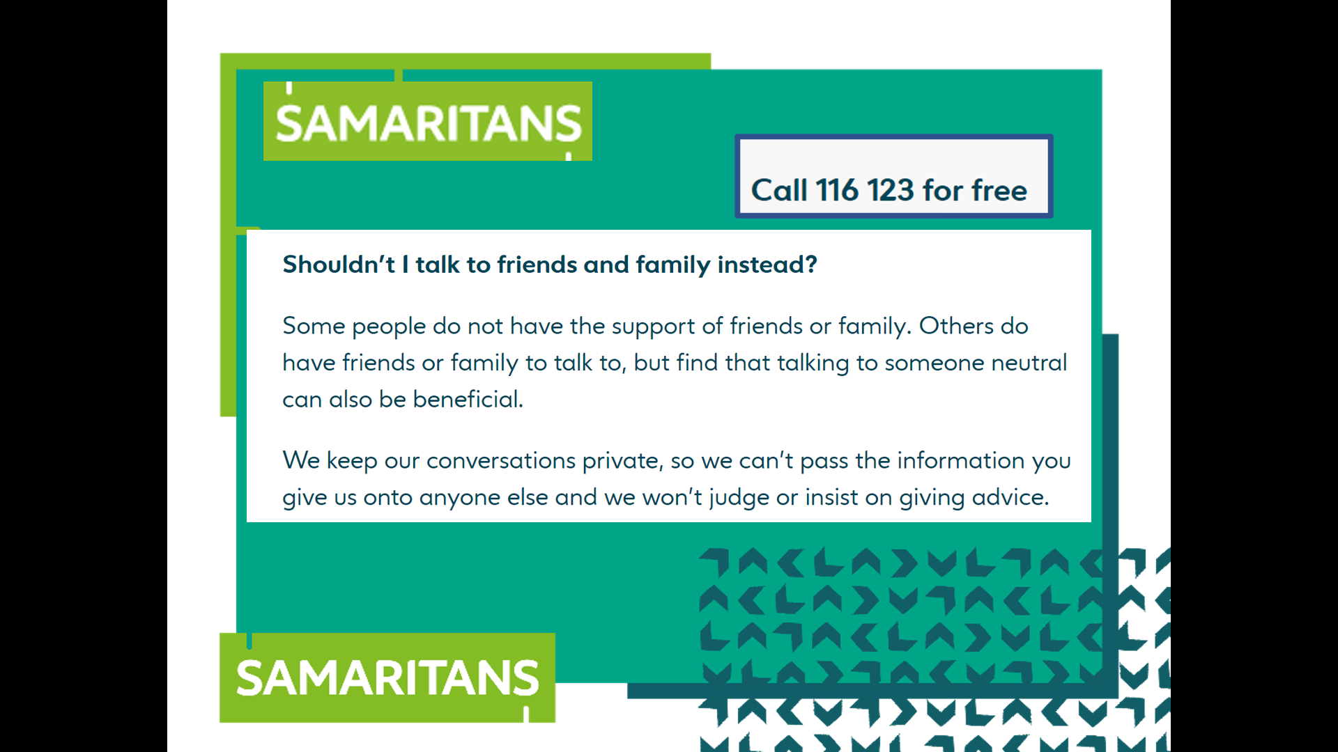
Sometimes, talking to someone without an emotional investment in your welfare can be liberating.
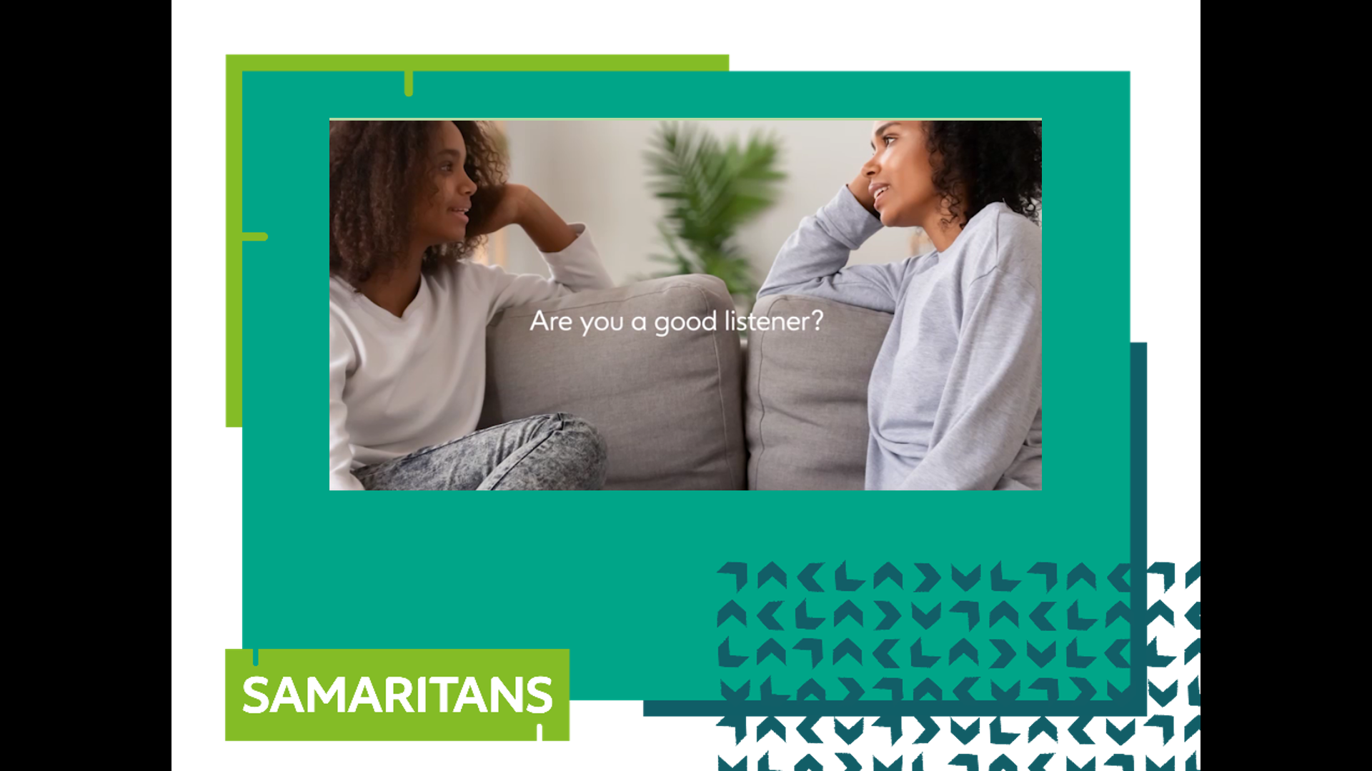
0:40-0:50

Role Play – How to support your friends
We are now going to act out a short role play. You will have to use your imagination because xxx and I will play two teenagers. Afterwards, we want you to think about how much each of us was listening to each other. I will play someone who is particularly worried about something. How does xxx handle it? How much listening is taking place? How much does the conversation help me?
Read the role play (next page)

Was the friend being thoughtless? Or trying to help? Did I get to say what I wanted? Would going to my friend’s house to play on his X Box, provide a solution to my worries.

Split the class into small groups to discuss how the conversation went. After 5 minutes, have a class discussion about how the conversation went. Ask the class what makes a good listener.

A | All right?
B | Yeah. You?
A | Not bad.
B | Do any revision last night?
A | You sound like my Mum.
B | (in ridiculous strict “Mum” voice) Do any revision last night?
A | That’s pretty good.
B | I know.
A | I tried but I’m finding History really hard
B | Me too
A | Really?
B | Oh yeah. I mean, who cares about Edward I?
A | Oh I quite like all that, to be honest. Edward I. Henry III. Wales. France. It’s interesting
B | I don’t care. When it’s all too boring, I just go on my X-Box
A | It’s not boring to me but…
B | Elden Ring is excellent. It’s good for studying history. Castles, Queens, Rings. You should come round tonight. Do you want to?
A | …er yes. Thanks. It’s just that I’m not coping. I find I’m making notes and…
B | Nah. Don’t worry about that. You’ll be fine. You’re always working hard. You know much more than I do. You’re really clever.
A | I don’t feel it. I’ve got 25 pages of notes on the relationship between Edward I and..
B | 25 pages? That’s brilliant.
A | Do you think so?
B | Yes. Fantastic. I’ve got 2 pages. I’m going to fail. You’ll be great.
A | Are you sure?
B | Of course. See you tonight. Come round about 6:00

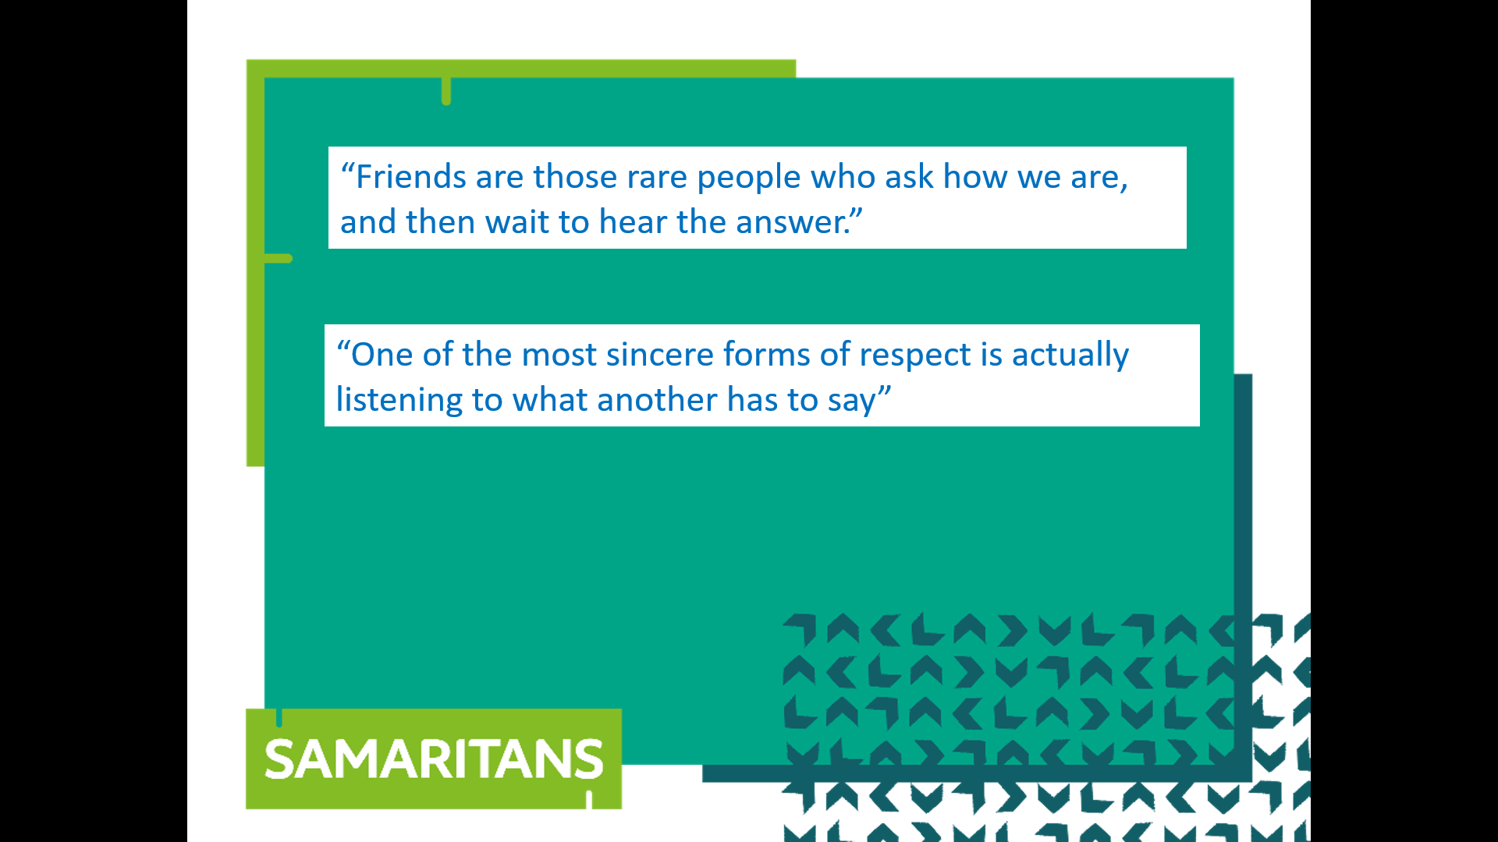
0:50-0:55

Questions

That brings us to the end of our session. We hope that you now know a little bit more about Samaritans and a bit more about the power of listening. Has anybody got any questions?

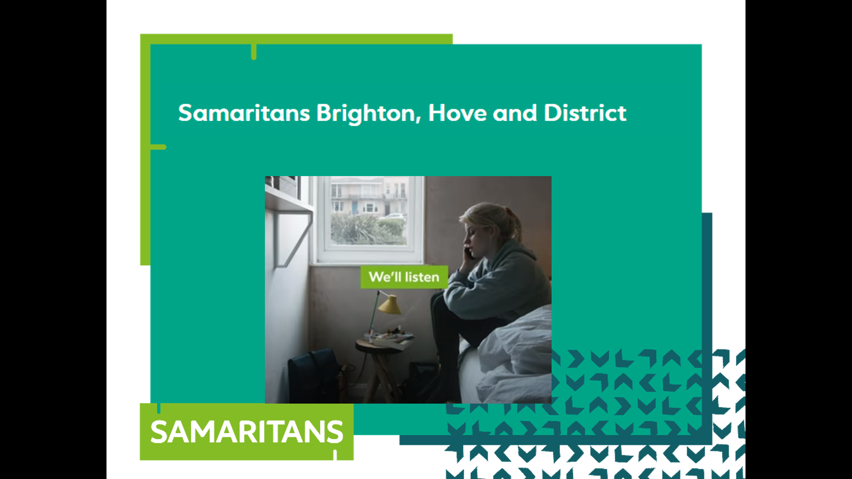
0:55-1:00

Finish

Teacher ends lesson. Bow to the applause. Receive gifts of appreciation modestly.

