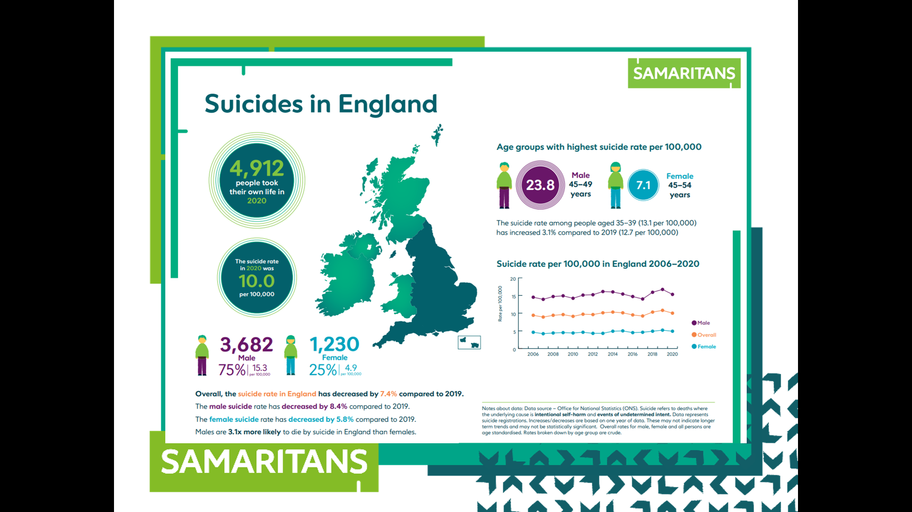
0:25-0:30

Suicide
We talked earlier about trying to prevent suicide.
In 2020, 4912 people in England took their own life. 75% of those people were male and 25% were female. Why do you think that might be?

Whole class discussion. Take answers from class. One reason may be that males are less willing to talk about their feelings to each other.

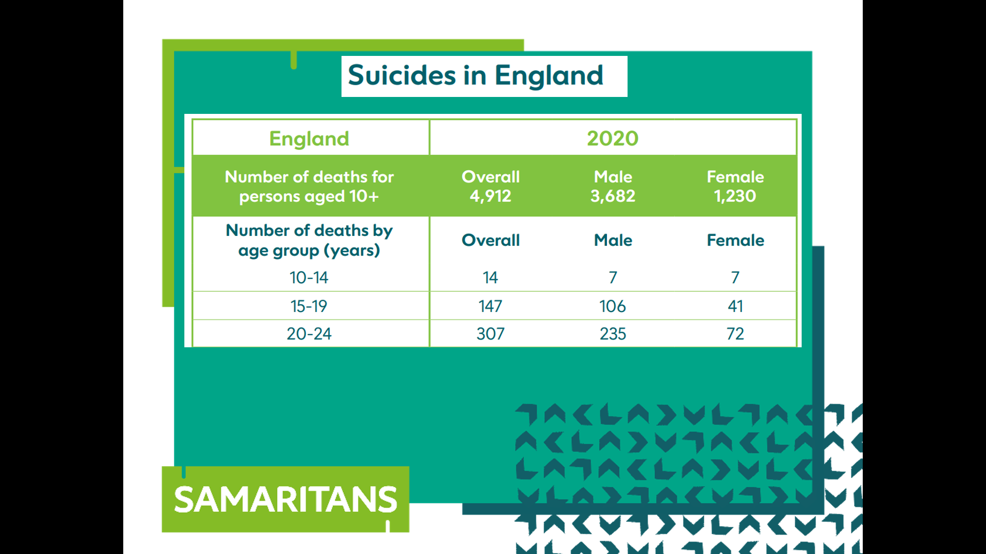
Very sadly, 147 people aged 15-19 took their own lives in 2020.

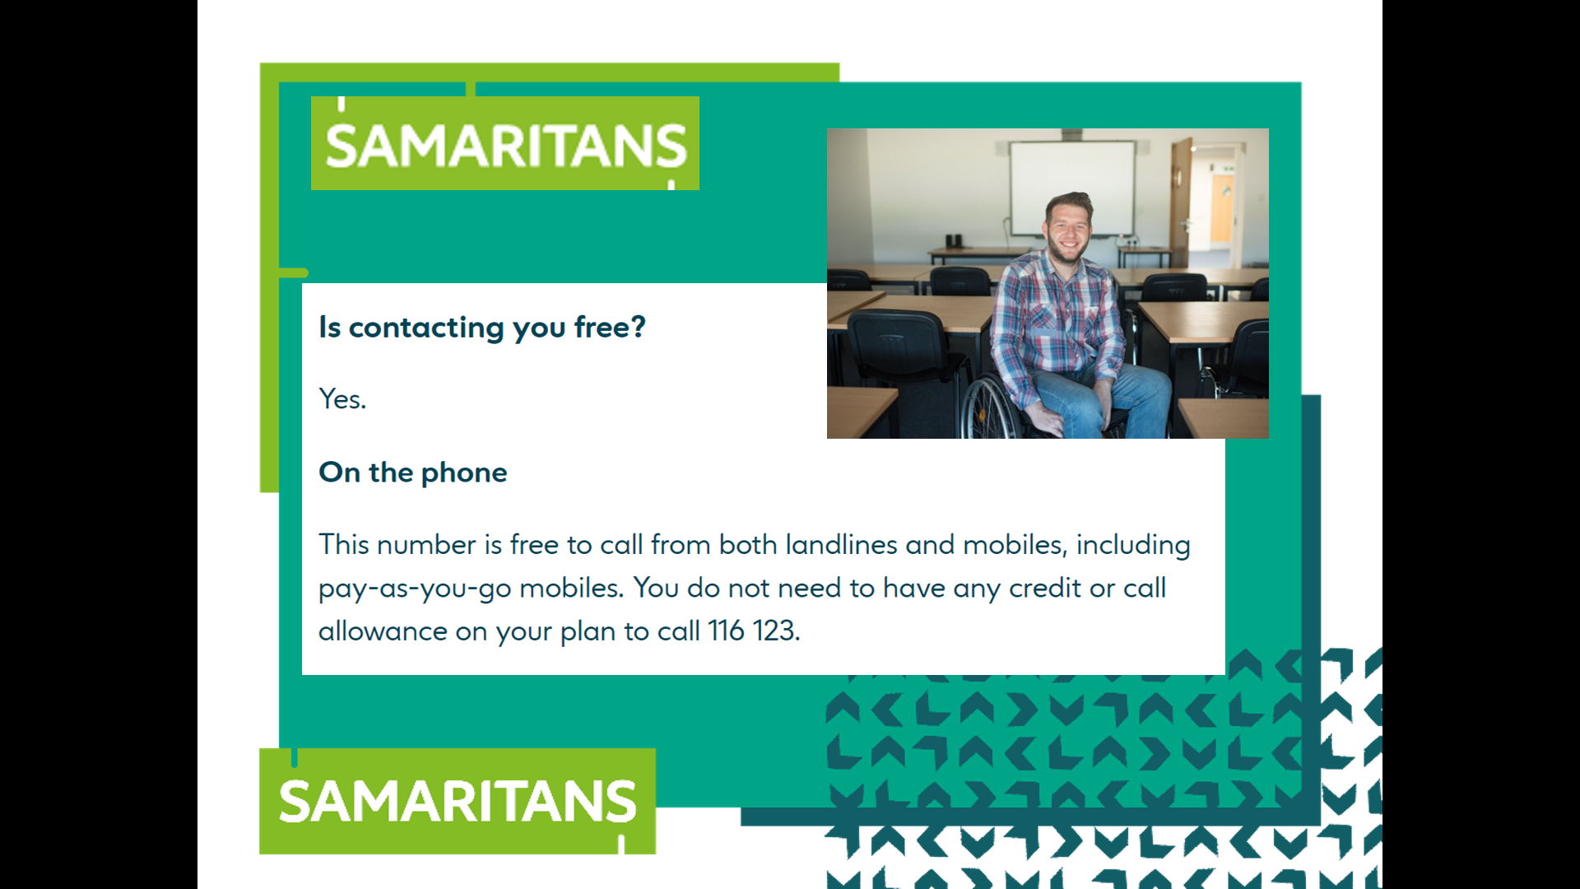
0:30-0:40

How The Samaritans works

Calls to The Samaritans are free

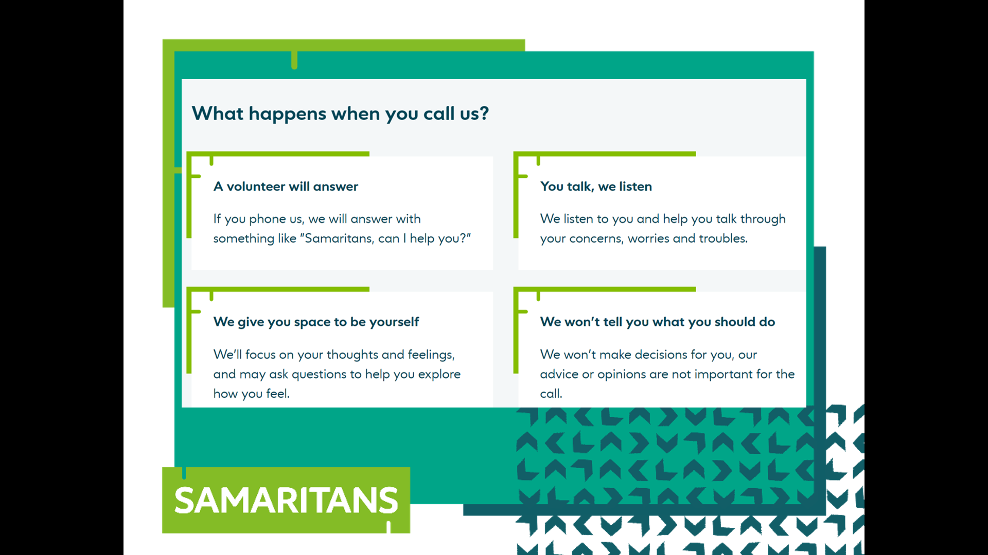
When you call us, we give you space to talk. We listen and we don’t tell you what to do.

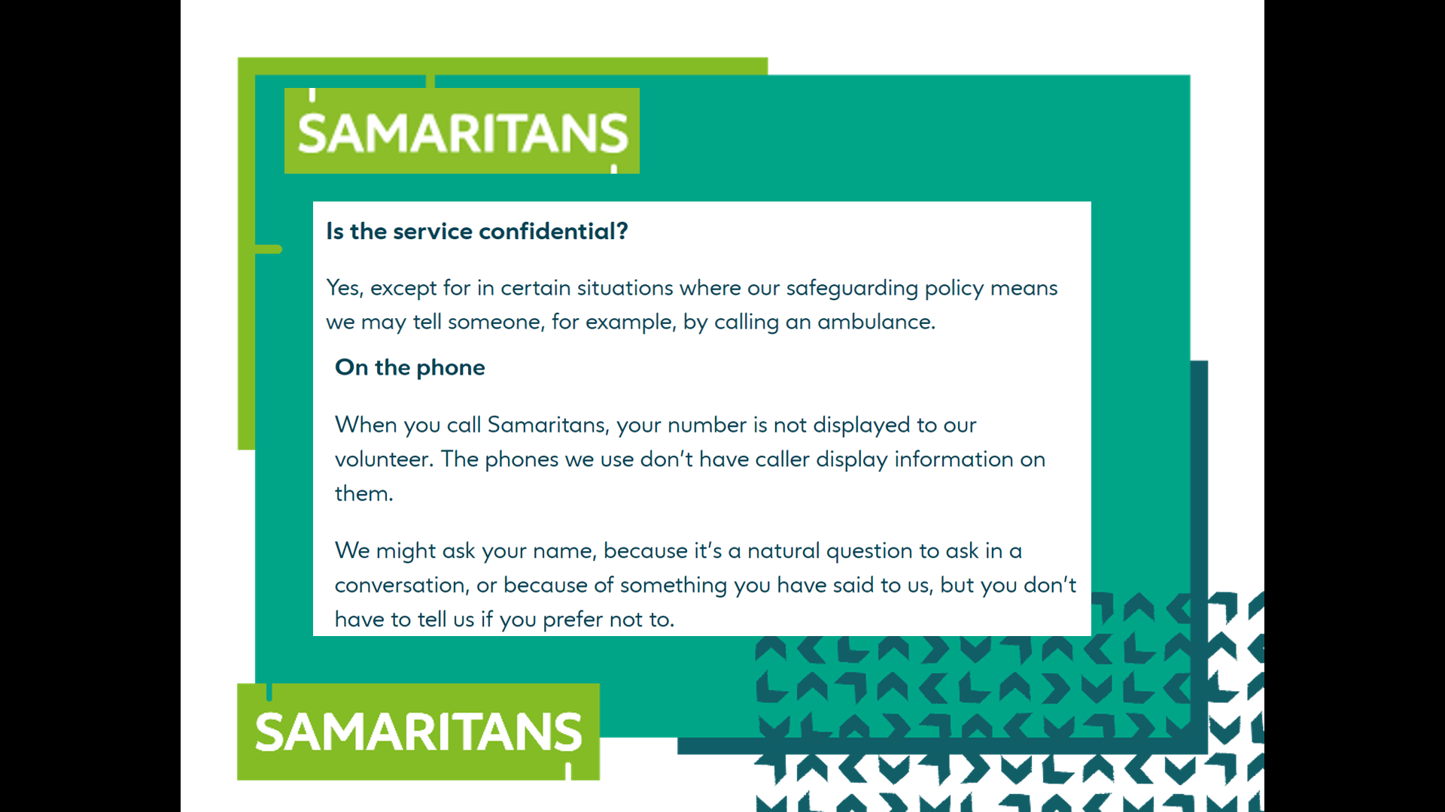
Samaritans don’t know the number you call from. We have no way of contacting you unless you tell us. In certain situations, we may express concern for your safety and ask for your name and address but if you don’t tell us, we won’t be able to offer help (like an ambulance).
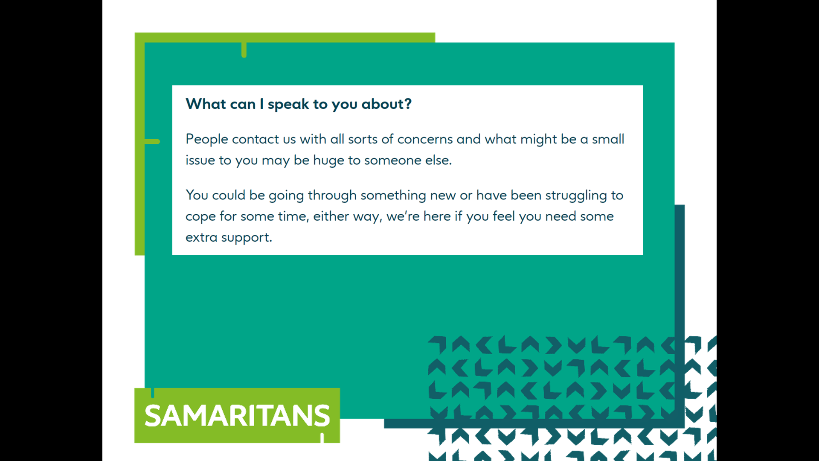
People contact us about all sorts of things

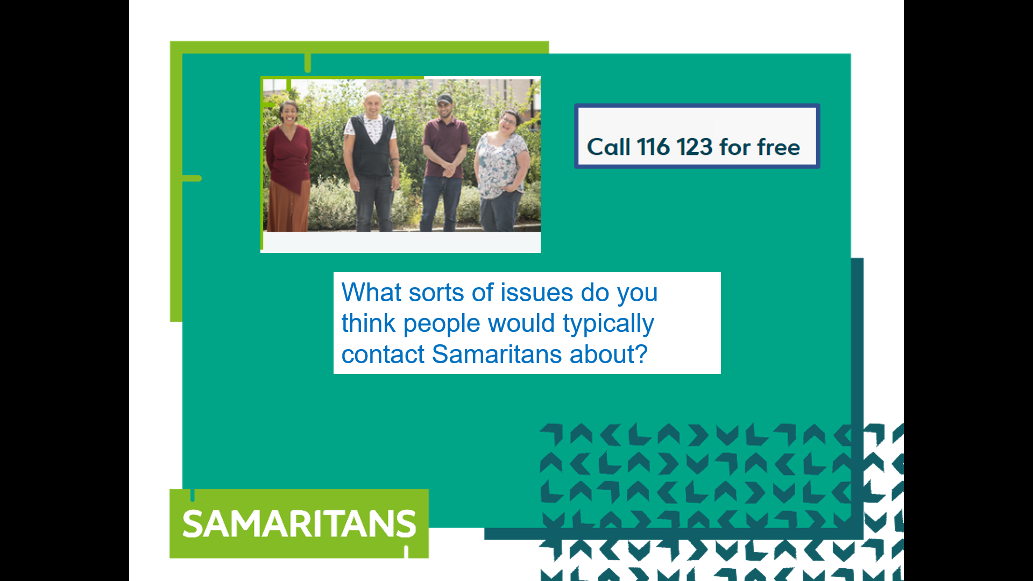
What sorts of issues do you think people would phone us about? Discuss this in your small groups. After 5 minutes, take some answers from the groups.

