Samaritans Presentation to Key Stage 4 Students
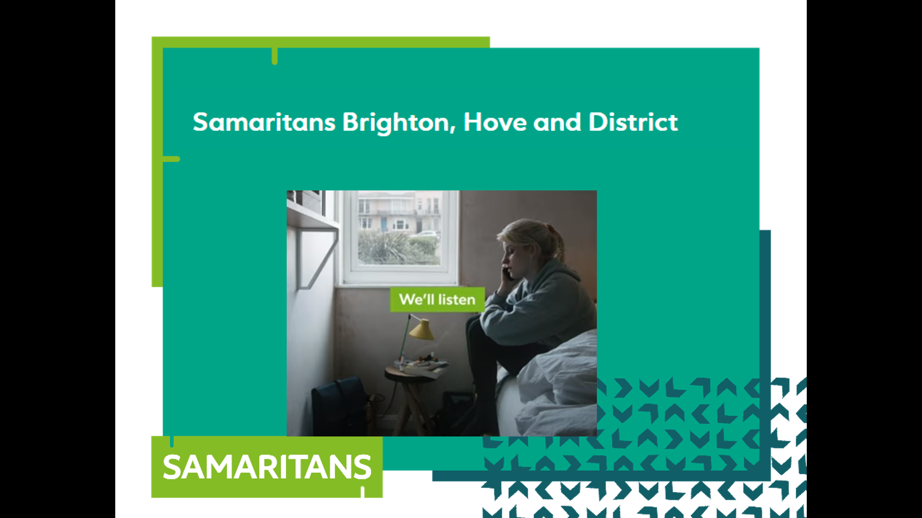

0:00 - 0:05 Beginning
0:05 - 0:10 Introduction to Samaritans
0:10 - 0:15 Child Line
0:15 - 0:25 Watching others for signs of distress
0:25 - 0:30 Suicide
0:30 - 0:40 How The Samaritans works
0:40 - 0:50 Role Play – How to support your friends
0:50 - 0:55 Finish

Equipment needed
- Powerpoint presentation
- One pen for each student
- Post-it notes for discussion (optional)
- These notes!

0:00 – 0:05

Beginning

Students enter room. Teacher takes register. We are introduced. Hand out free pens. Hopefully no more than 5 minutes

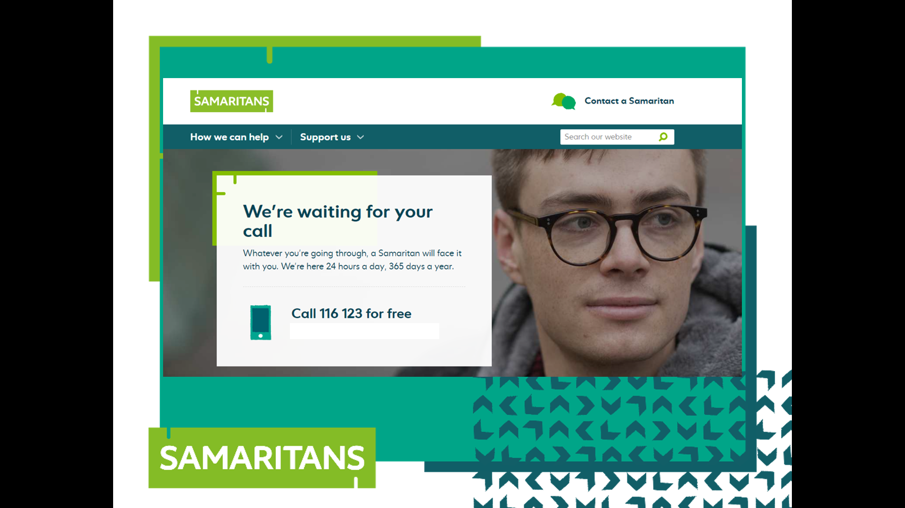
0:05 – 0:10

Introduction to Samaritans

My name is xxx and this is xxx. We are from The Samaritans in Brighton. Some of the discussion today may be upsetting to you. If you feel upset, please let your teacher know. Does anybody know what The Samaritans organisation does?

Whole class discussion. This might be a good time to emphasise that we are not a religious organisation.

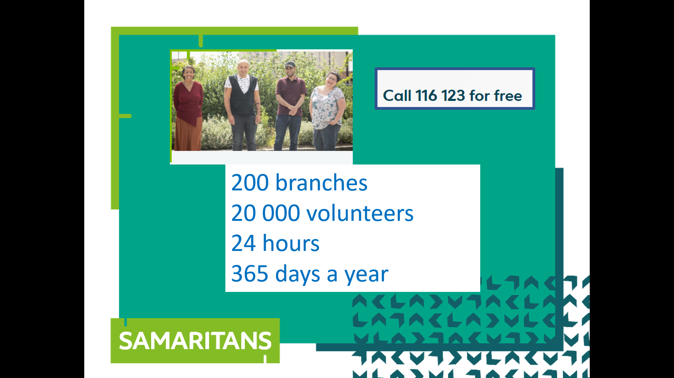
In the whole of the U.K. there are about 200 branches. Ours is in Hove. Over 20 000 people volunteer. In Brighton & Hove there are about 140 volunteers. When you contact Samaritans, you get put through to any one of the branches in the country. Someone will answer any time of day

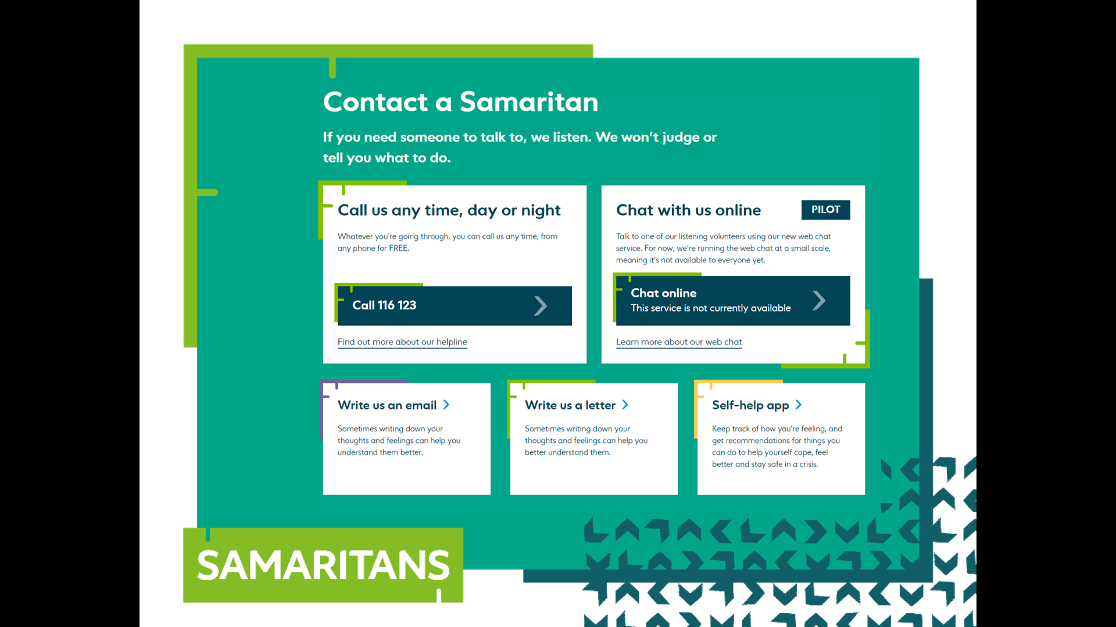
Anyone can contact Samaritans on the phone, by email and online chat (available at certain times). People can even write to us and before COVID, people could talk to us face-to-face.

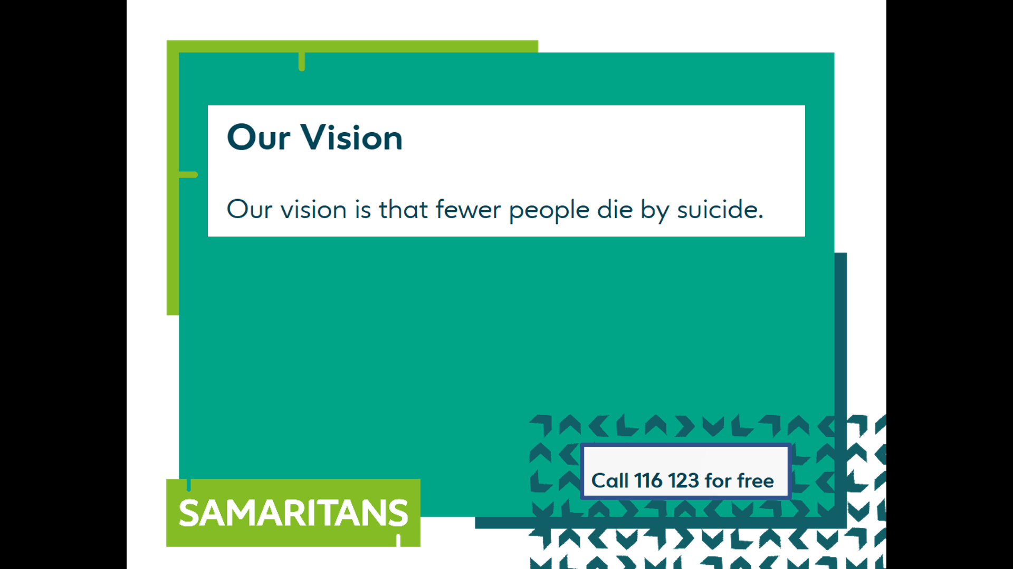
Our “vision” is to help to reduce the number of people that die by suicide.

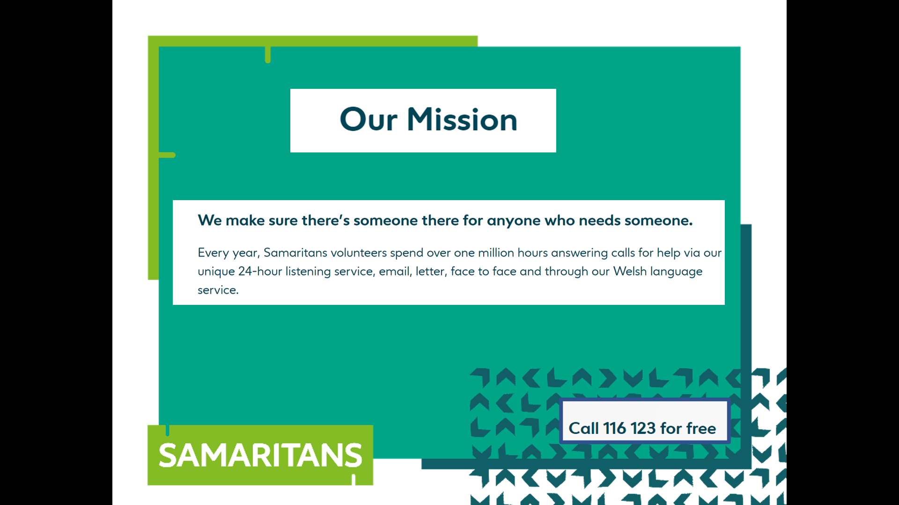
We try to do this by making ourselves available to listen to anyone who needs someone to talk to. We are available to anyone of any age. We are here today to tell you about The Samaritans and also to pass on a few tips about how you can support your friends if they are going through a tough time.
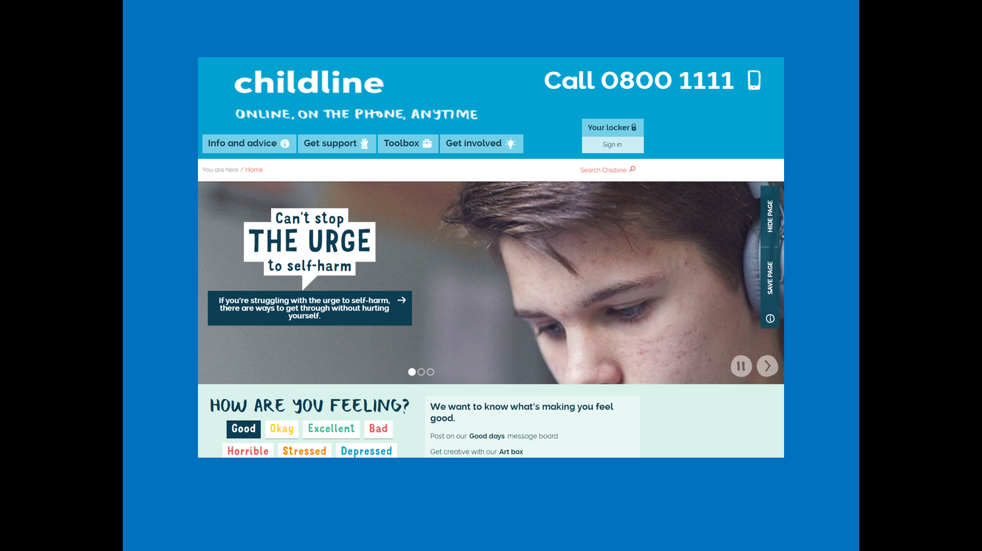
0:10-0:15

Child Line

We are separate to Child Line.

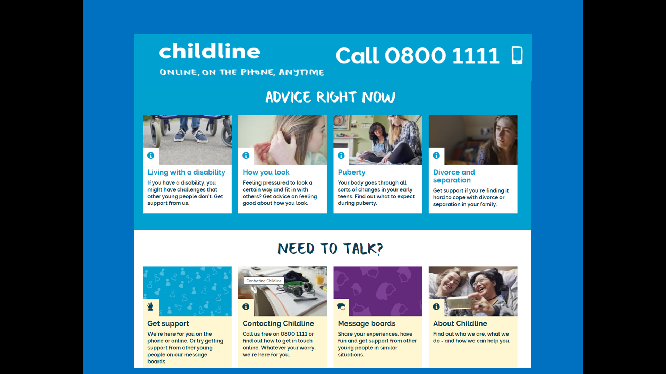
The people who answer phones at Child Line are specifically trained to listen to anyone under the age of 18. We are trained to listen to callers of any age.

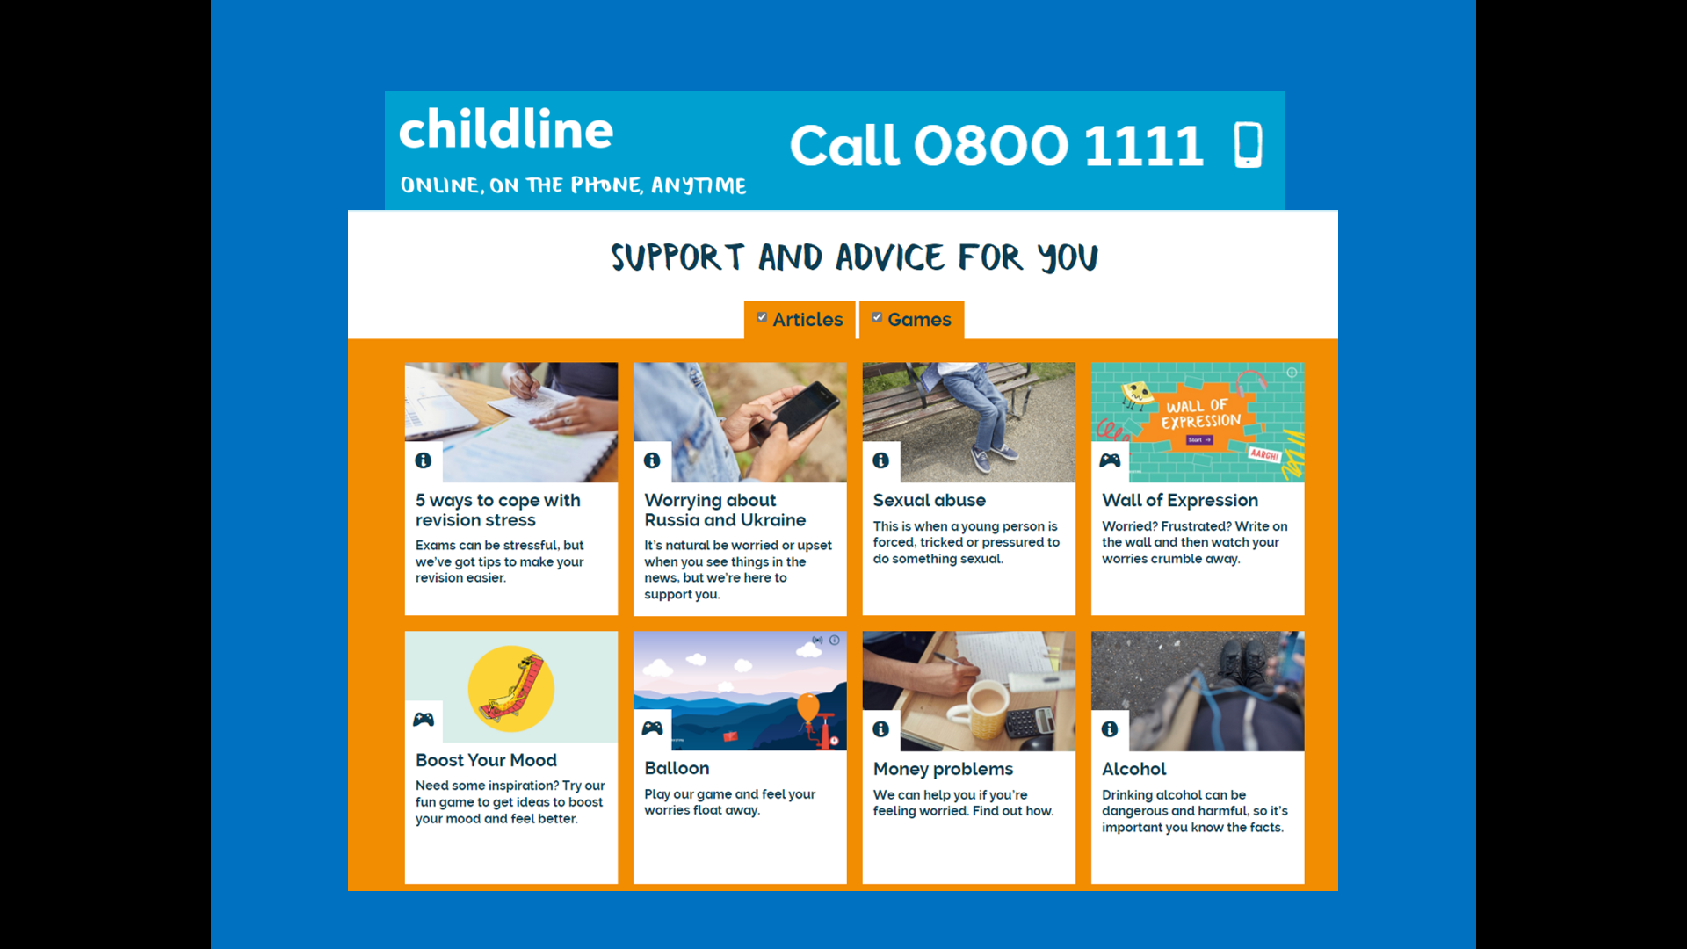
There is lots of good advice on the Child Line website as you can see from this snapshot of their website.

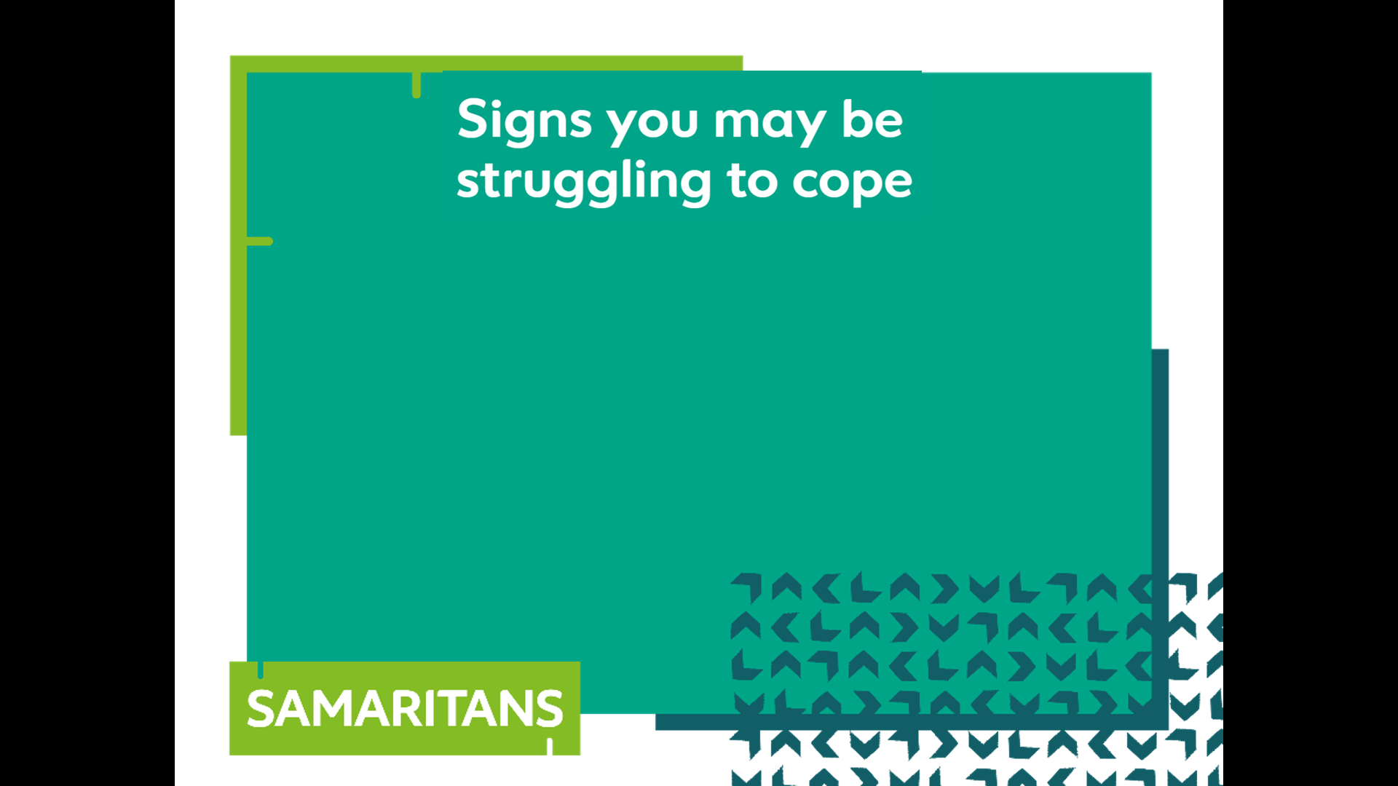
0:15-0:25

Watching others for signs of distress

We said that we are here to support anyone who is going through a tough time. Sometimes your friends will come right out and say, “I’m feeling really stressed at the moment”. However, at other times, they won’t say that but their behaviour might change. What signs are there do you think that someone might be struggling. Discuss this in small groups.
You might like to give out post-it notes for the students to record their discussions but this is not essential.
After 5 minutes, take some answers from the groups.

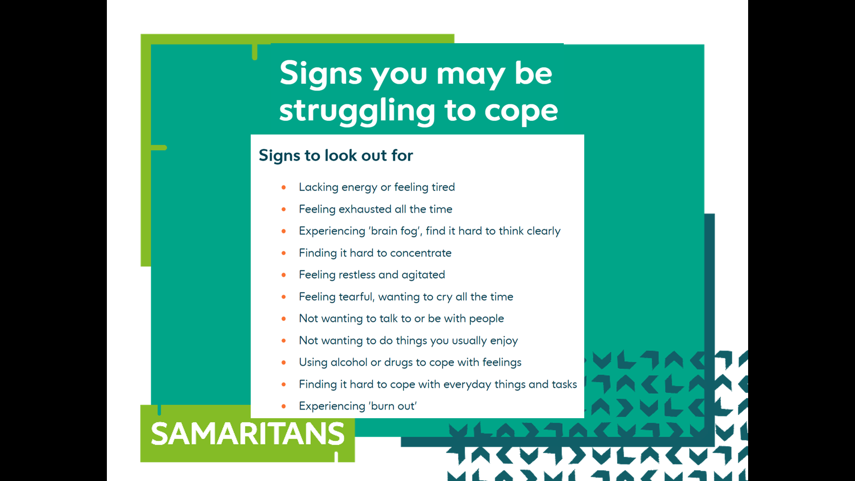
Display our list
Here is the list that appears on the Samaritans website.
Compare the Samaritans list with the list from the class.

