Sketching Cubic Graphs 2
Sketch these graphs
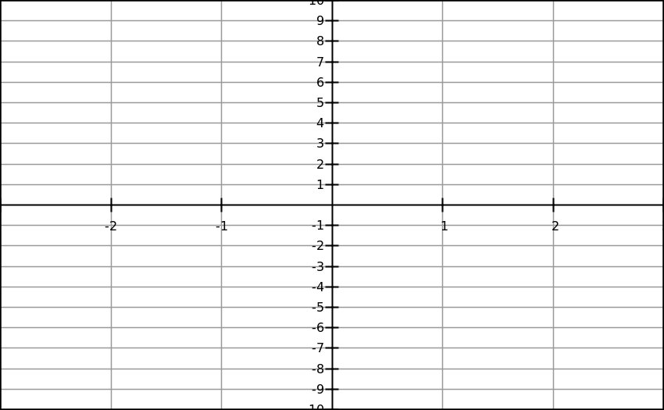
- y = (x – 1)( x + 1 )(x + 2) 2) y = -(x – 1)(x + 1 )( x + 2)
3) y = (x – 2)² (x + 1) 4) y = (2 – x)² (x + 1)

5) y = (-x -1) ³ 6) y = -(2 – x)³

