A2 Maths with Mechanics Test (pi) Version O

1) Evaluate , giving an exact answer.

2**)** Solve the equation ()

3) Sketch Show clearly any asymptotes, vertical and horizontal, and any crossings with the coordinate axes.

4) Eliminate t from this pair of equations:

5) A particle *P* of mass 0.5 kg is moving under the action of a single force **F** Newtons. At time *t* seconds, **F** = (1.5*t* 2 – 3)**i** + 2*t***j**.

When *t* = 2, the velocity of *P* is 

(*a*) Find the acceleration of *P* at time *t* seconds.

(*b*) Find the velocity of P when *t* = 3

6) U

A2 Maths with Mechanics Test (pi) Version P

1) Evaluate , giving an exact answer.

2**)** Solve the equation ()

3) Sketch Show clearly any asymptotes, vertical and horizontal, and any crossings with the coordinate axes.

4) Eliminate t from this pair of equations:

5) A particle *P* of mass 2 kg is moving under the action of a single force **F** Newtons. At time *t* seconds, **F** = (1.5*t* 2 – 3)**i** + 2*t***j**.

When *t* = 2, the velocity of *P* is 

(*a*) Find the acceleration of *P* at time *t* seconds.

(*b*) Find the velocity of P when *t* = 3

6) U

A2 Maths with Mechanics Test (pi) Version Q

1) Evaluate , giving an exact answer.

2**)** Solve the equation ()

3) Sketch Show clearly any asymptotes, vertical and horizontal, and any crossings with the coordinate axes.

4) Eliminate t from this pair of equations:

5) A particle *P* of mass 0.25 kg is moving under the action of a single force **F** Newtons. At time *t* seconds, **F** = (1.5*t* 2 – 3)**i** + 2*t***j**. When *t* = 2, the velocity of *P* is 

(*a*) Find the acceleration of *P* at time *t* seconds.

(*b*) Find the velocity of P when *t* = 3

6) U

A2 Maths with Mechanics Test (pi) Version R

1) Evaluate , giving an exact answer.

2**)** Solve the equation ()

3) Sketch Show clearly any asymptotes, vertical and horizontal, and any crossings with the coordinate axes.

4) Eliminate t from this pair of equations:

5) A particle *P* of mass 0.1 kg is moving under the action of a single force **F** Newtons. At time *t* seconds, **F** = (1.5*t* 2 – 3)**i** + 2*t***j**.

When *t* = 2, the velocity of *P* is 

(*a*) Find the acceleration of *P* at time *t* seconds.

(*b*) Find the velocity of P when *t* = 3

6) U

**Answers Version O**



2) 210, 270, 330

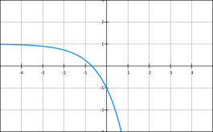

3)

4)

5) a) + 4t**j**

b)

6)

**Answers version P**

2) 210, 270, 330

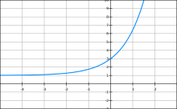

3)

4)

5) a) + t**j**

b) **v =**

6)

**Answers version Q**

2) 210, 270 $°$, 330 $°$

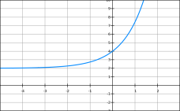

3)

4) ${x^{2}+ y}^{2}=1$

5a) $a=(6t^{2}-12)i$ + 8t**j**

b) 22**i** + 25**j**

6) $\frac{1}{2}+\frac{3}{2}e^{4}$

**Answers Version R**

2) 210, 270, 330

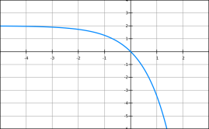

3)

4)

5) a) + 20t**j**

b) **v** = **i +** 55 **j**

6) $\frac{1}{2}e^{a^{2}}(a^{2}-1)$