**C3**

**C4**

**D1**

**A2**

**Maths Survival Kit**

**Name…………………………………….**

**www.mickmacve.com**

|  |  |  |
| --- | --- | --- |
| Week beginning | Videos | Page |
| June/July | C3 Algebraic Fractions | 3 |
| June/July | C3 Algebraic Division | 4 |
| June/July | C3 Reciprocal Trig Functions | 5 |
| June/July | C3 Pythagorean Identities | 6 |
| June/July | C3 Trig Consolidation | 7 |
| June/July | C3 Chain Rule | 8 |
| June/July | C3 The Product Rule | 9 |
| June/July | C3 The Quotient Rule | 10 |
| June/July | C3 Differentiating trig functions | 11 |
| June/July | C3 The Compound Angle Formulae | 12 |
| June/July | C3 The Double Angle Formulae | 13 |
| June/July | C3 The Factor Formulae | 14 |
| June/July | C3 Natural logs including derivatives of e^x and lnx | 15 |
| June/July | C3: Integration as the inverse of differentiation | 16 |

|  |  |  |  |
| --- | --- | --- | --- |
| Week beginning | Lesson | Video | Page |
| 11th September | 1 | C3: Revision for CWC 1: Algebraic Fractions | 17 |
| 18th September | 1 | C3: Revision for CWC 2: Differentiating ln | 18 |
|  | 2 | C3: Revision for CWC 3: Product and Quotient Rule | 19 |
|  | 3 | C3: Revision for CWC 4: Trig proofs | 20 |
| 25th September | 1 | C3: Functions – Domain, Range, Composite | 21 |
| 2nd October | 1 | C3 Functions – Modulus, Inverse, Transformations | 22 |
| 9th October | 1 | C3 Numerical Methods | 23 |
| 16th October | 2 | C3 Rcos(x+a) | 24 |
|  | 2 | C3 Inverse trig functions including graphs | 25 |
| 30th October | 1 | C3: dy/dx = 1/ (dx/dy) | 26 |
|  | 2 | C4 Implicit Differentiation | 27 |
| 6th November | 1 | C4 Binomial Expansion | 28 |
|  | 2 | C4 Partial fractions | 29 |
| 13th November |  | Reading week – no lessons |  |
| 20th November |  | D1 Algorithms, Bubble Sort, Quick Sort, Bin Packing, Binary Search |  |
| 27th November | 1 | C4 Integration using Trig, Partial Fractions, ln x | 31 |
|  | 2 | C4 Trapezium Rule and percentage error | 33 |
| 4th December |  | D1 Dijkstra, Kruskal, Prim |  |
| 11th December | 1 | C4 Integration by Parts | 34 |
|  | 2 | C4 Integration by Substitution | 35 |
| 1st January |  | D1 Route Inspection |  |
| 8th January |  | D1 Linear Programming |  |
| 15th January | 1 | C4 Connected Rates of Change | 36 |
| 22nd January | 1 | C4 Vectors – Introduction | 37 |
|  | 2 | C4 vectors – Scalar (dot) product | 38 |
|  | 3 | C4 Vectors – Vector equation of a line | 39 |
| 29th January |  | D1 Critical Path Analysis |  |
| 5th February | 1 | C4 Forming Differential Equations | 40 |
|  | 2 | C4 Differential Equations | 41 |
| 19th February |  | D1 Gantt Charts |  |
| 26th February | 1 | C4 Parametrics | 42 |
| 5th March | 1 | C4 Volume of Solid of Revolution | 43 |
| 12th March |  | D1 Matchings |  |

The D1 Survival Kit is a separate book.

|  |  |
| --- | --- |
| **C3 : Algebraic Fractions** | |
| <https://youtu.be/MC90CB-s8QM>  http://blog.printpapa.com/wp-content/uploads/2010/08/78_2558195.jpg | C:\Users\Mick and Roo\AppData\Local\Microsoft\Windows\Temporary Internet Files\Content.IE5\5YRM7R83\qrcode.29596866.png |

Copy the two examples

1. Simplify $\frac{3x^{2}-x-2}{\left(\frac{1}{2}x+\frac{1}{3}\right)}$

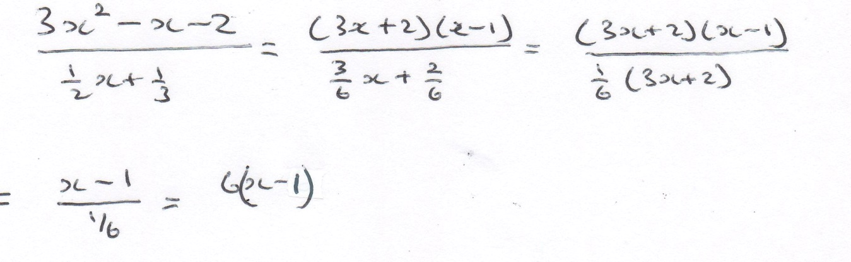

1. 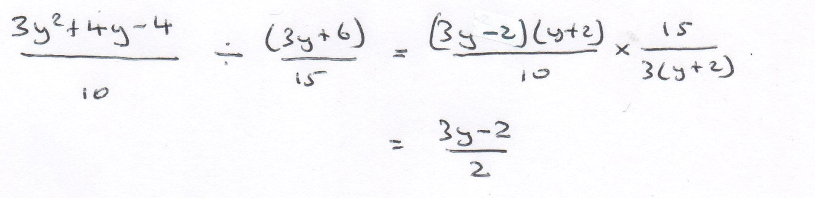Simplify $\frac{3y^{2}+4y-4}{10}$ ÷ $\frac{\left(3y+6\right)}{15}$

|  |  |
| --- | --- |
| **C3 Algebraic Division** | |
| <https://youtu.be/tfjYIrkvalI>  [http://thumbs.dreamstime.com/z/blank-clipboard-notepad-isolated-white-8448708.jpg](http://www.google.co.uk/url?sa=i&rct=j&q=&esrc=s&source=images&cd=&cad=rja&uact=8&ved=0CAcQjRw&url=http://www.dreamstime.com/royalty-free-stock-photos-blank-clipboard-notepad-isolated-white-image8448708&ei=_eZaVbiWE9TQ7AaH8YLgDQ&bvm=bv.93564037,d.ZGU&psig=AFQjCNGqUk1dX5yvGCJm-SxQf3ZrhZbHwg&ust=1432107041817445) | C:\Users\Mick and Roo\AppData\Local\Microsoft\Windows\Temporary Internet Files\Content.IE5\0CQVB242\qrcode.29596979.png |

Copy the example $\frac{4x^{3}-5x^{2}+3x-14}{x^{2}+2x-1}$

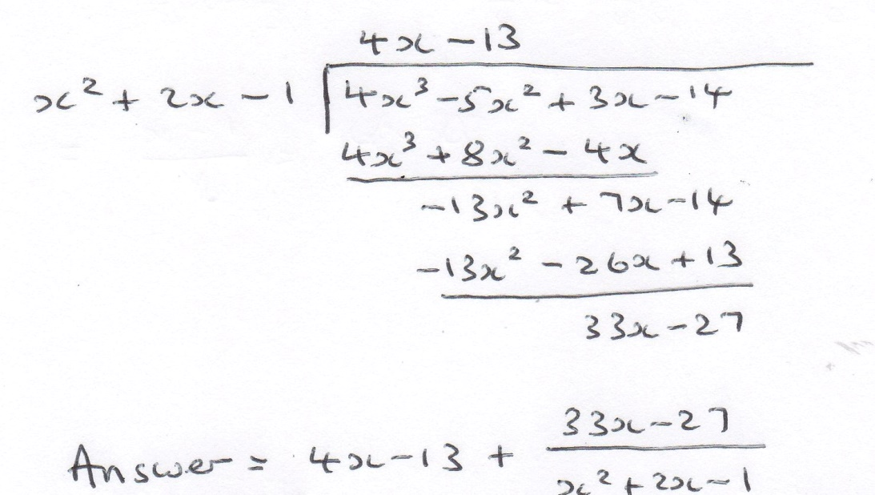

|  |  |
| --- | --- |
| **C3: Reciprocal Trig Functions** | |
| <https://youtu.be/5mpYSXxktHU> | C:\Users\Mick and Roo\AppData\Local\Microsoft\Windows\Temporary Internet Files\Content.IE5\KFCF9TXG\qrcode.29609458.png |

Complete the table

|  |  |  |  |  |  |
| --- | --- | --- | --- | --- | --- |
| sec x = | $$\frac{1}{\cos{x}}$$ | cosec x = | $$\frac{1}{\sin{x}}$$ | cot x = | $$\frac{1}{\tan{x}}$$ |

Draw the graphs of

y = sec x, y = cosec x

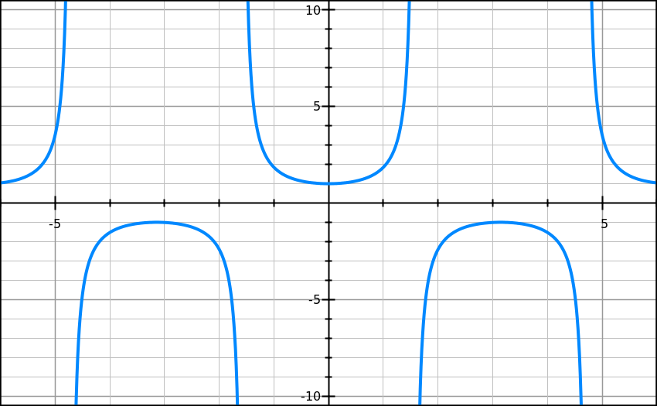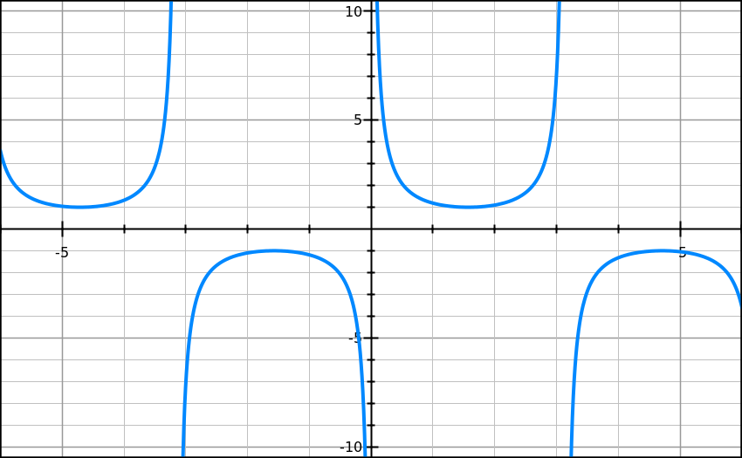

y

y = cot x

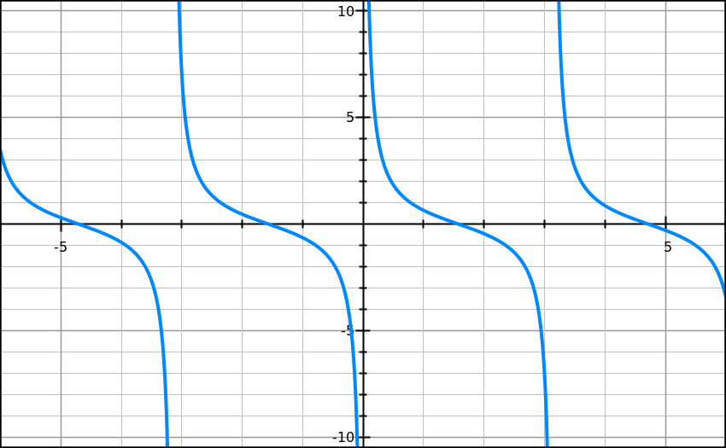

When proving a trig identity, how should you start the proof and how should you finish the proof?

**Start with LHS ≡ and end with ≡ RHS ( or vice versa). The last thing you should write is “Proof Complete” (or Q.E.D. if you like your Latin)**

What is the difference between = and ≡

**= means “equals” and is used to solve equations**

**≡ means “is identical to” and is used when algebraic expressions are identical**

**e.g. $x^{2}=4$ is only true for two values of x**

e.g. $x^{2}-4 (x-2)(x+2)$ is true for every value of x

|  |  |
| --- | --- |
| C3 **Pythagorean Identities** | |
| <https://youtu.be/VcDtYgSDvRs> | C:\Users\Mick and Roo\AppData\Local\Microsoft\Windows\Temporary Internet Files\Content.IE5\0CQVB242\qrcode.29610413.png |

There are three Pythagorean identities (one of which you had to know for C2).

What are they? $\sin^{2}{x+\cos^{2}{x=1}}$

$$1+\tan^{2}{x=\sec^{2}{x}}$$

$$1+\cot^{2}{x=cosec^{2}x}$$

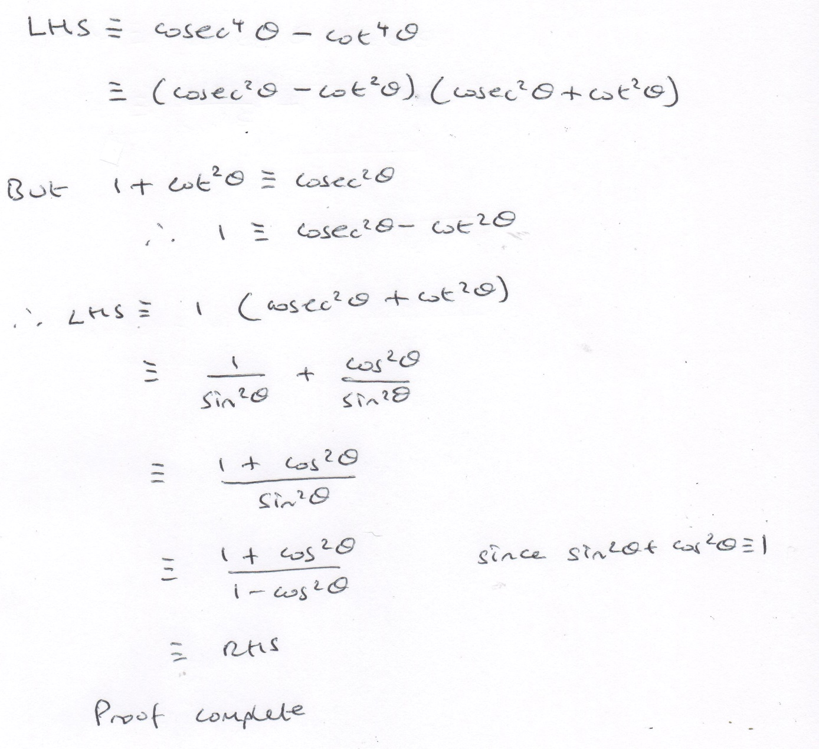Prove that $cosec^{4}$- $\cot^{4}{ }$ ≡ $\frac{1+\cos^{2}{}}{1-\cos^{2}{}}$

|  |  |
| --- | --- |
| C3 **Trig Consolidation** | |
| http://www.zencollegelife.com/blog/wp-content/uploads/2009/03/notepad.jpg<https://youtu.be/zk8Bled7bFc> | C:\Users\m.macve.BHA\AppData\Local\Microsoft\Windows\Temporary Internet Files\Content.IE5\L7P3VPGU\qrcode.29679131.png |

Solve the equation $4cosec^{2}θ-9$ = cot θ. Show full working 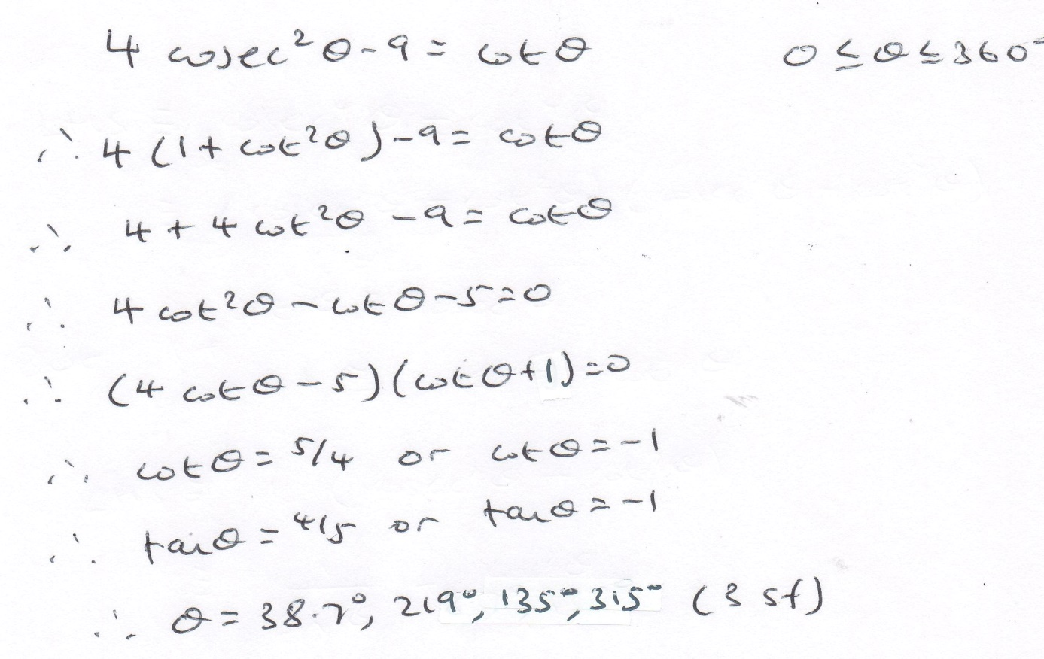

|  |  |
| --- | --- |
| **C3 Chain Rule** | |
| <https://youtu.be/YLSm56VIa6U>  http://www.photosinbox.com/download/blank-notepad.jpg | C:\Users\m.macve.BHA\AppData\Local\Microsoft\Windows\Temporary Internet Files\Content.IE5\0S2YLTWC\qrcode.29677045.png |

If y = , what is $\frac{dy}{dx}$.

$\frac{dy}{dx}=6{\left(5x^{3}-2x\right)}^{5}(15x^{2}-2)$

|  |  |
| --- | --- |
| **C3:The Product Rule** | |
| <https://youtu.be/Jpg3QX5slg4> | C:\Users\m.macve.BHA\AppData\Local\Microsoft\Windows\Temporary Internet Files\Content.IE5\L7P3VPGU\qrcode.29676879.png |



If y = f(x) g(x), what is $\frac{dy}{dx}$

**f’(x)g(x) + f(x)g’(x)**

If y = $x^{4}{\left(2x^{2}+3x\right)}^{5}$, what is $\frac{dy}{dx}$. Show the full working. 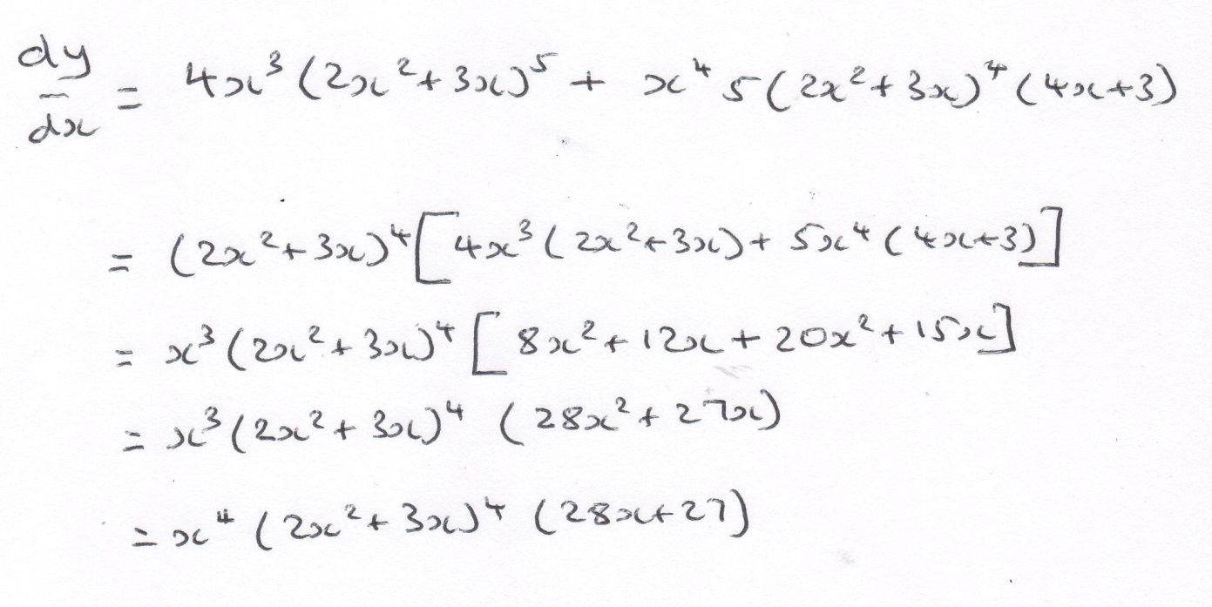

|  |  |
| --- | --- |
| **C3 The Quotient Rule** | |
| <https://youtu.be/aYzFUB5q7BI> | C:\Users\m.macve.BHA\AppData\Local\Microsoft\Windows\Temporary Internet Files\Content.IE5\ZP0XP5RC\qrcode.29666452.png |

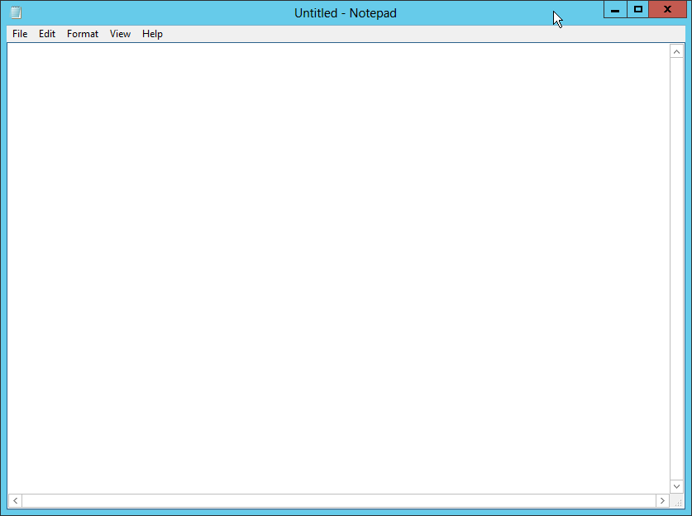

If y = where u and v are functions of x, what is $\frac{dy}{dx}?$

$$\frac{dy}{dx}=\frac{u'v-uv'}{v^{2}}$$

If y = $\frac{f(x)}{g(x)}$ what is $\frac{dy}{dx}?$

$$\frac{dy}{dx}=\frac{f^{'}\left(x\right)g\left(x\right)-f\left(x\right)g^{'}\left(x\right)}{{\left(g\left(x\right)\right)}^{2}}$$

If y = $\frac{{\left(x^{2}+5\right)}^{3}}{4x}$, what is $\frac{dy}{dx}$? Show the full working.

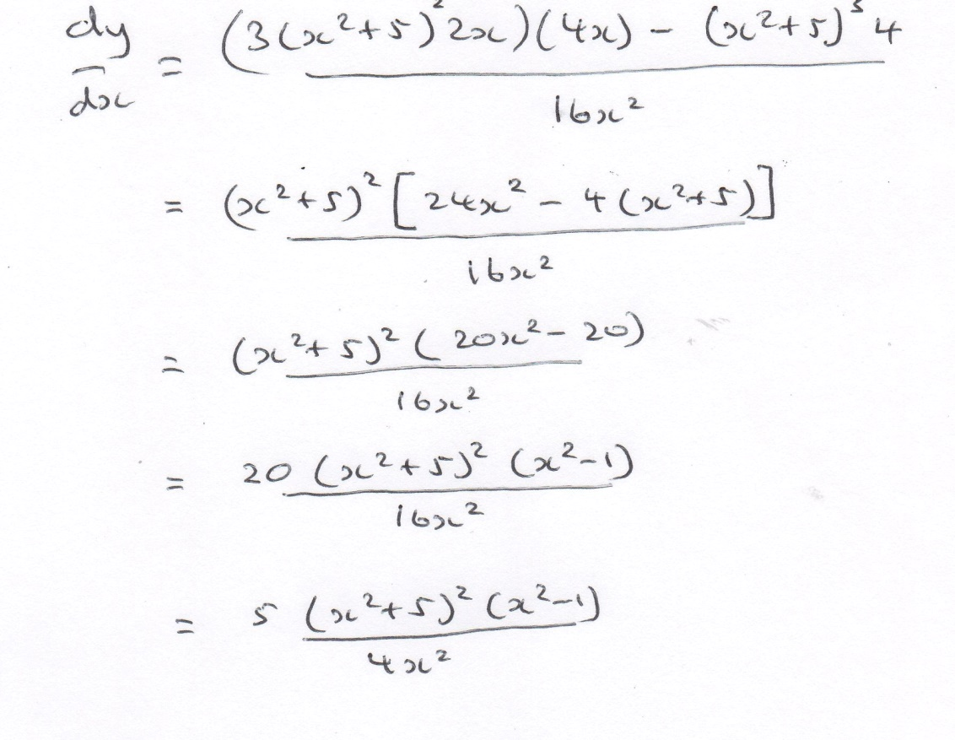

|  |  |
| --- | --- |
| **C3: Differentiating trig functions** | |
| <https://youtu.be/kQ0lvJtXIgY> | C:\Users\Mick and Roo\AppData\Local\Microsoft\Windows\Temporary Internet Files\Content.IE5\QUEJYM1X\qrcode.29701306.png |

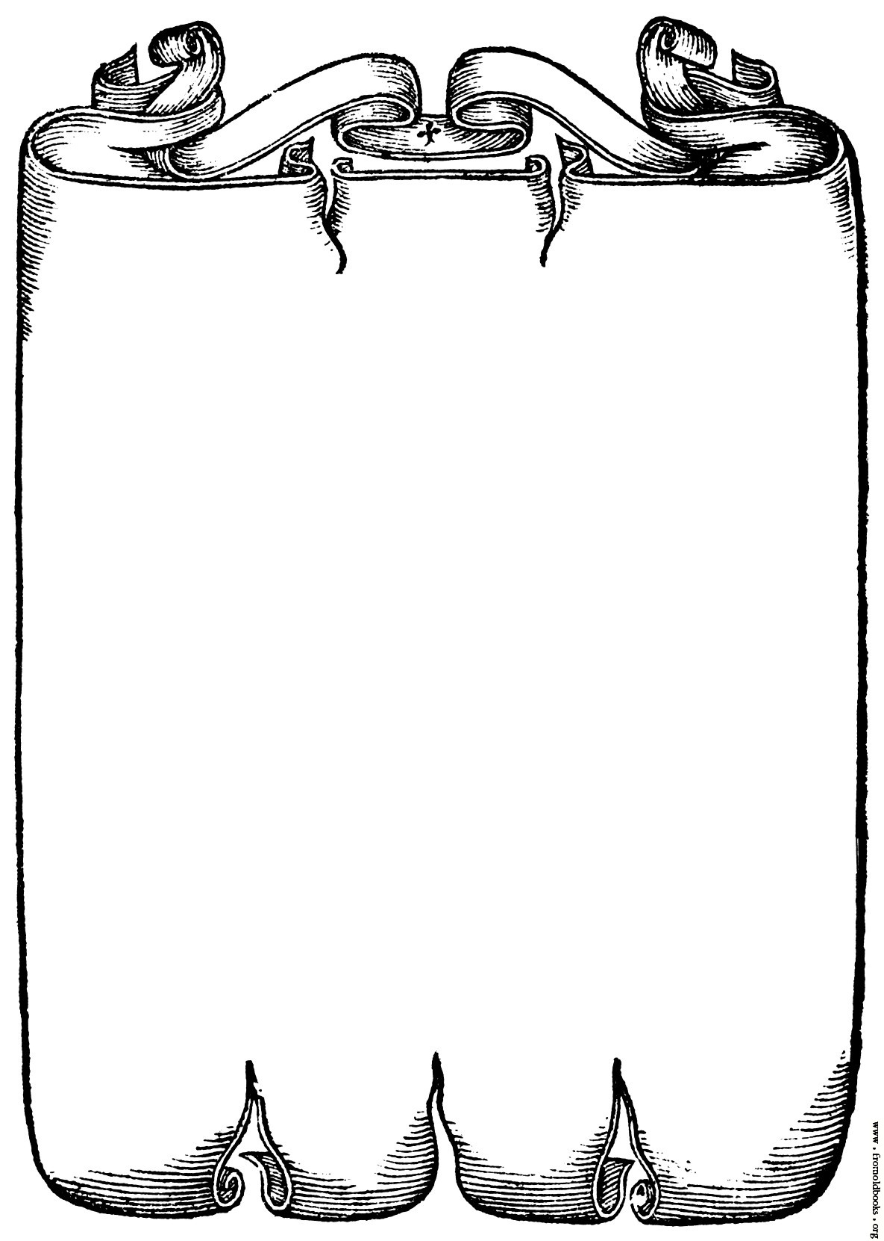 Complete this table

|  |  |
| --- | --- |
| **y** | $$\frac{dy}{dx}$$ |
| sin x | **cos x** |
| cos x | **-sin x** |
| tan x | $$\sec^{2}{x}$$ |
| sec x | **sec x tan x** |
| cosec x | **- cosec x cot x** |
| cot x | $$- cosec^{2}x$$ |

When differentiating a trig should you use radians or degrees? **RADIANS**

|  |  |
| --- | --- |
| **C3: The Compound Angle Formulae** | |
| <https://youtu.be/DyqQG7MzOPU> | C:\Users\Mick and Roo\AppData\Local\Microsoft\Windows\Temporary Internet Files\Content.IE5\5YRM7R83\qrcode.29701420.png |

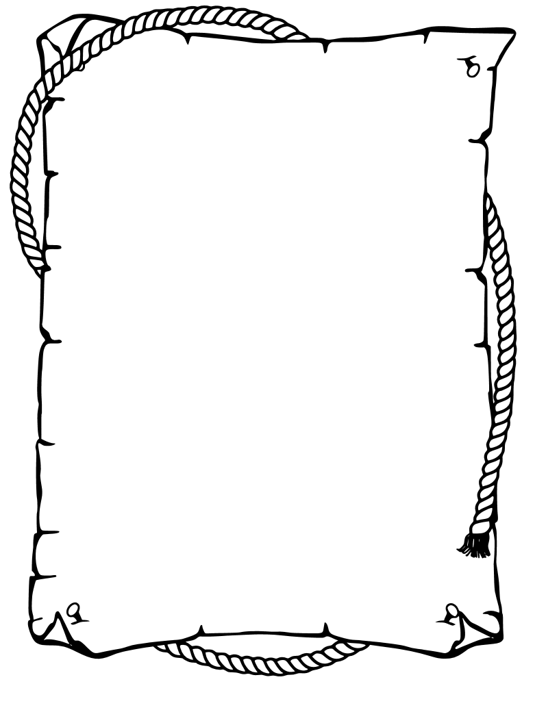

sin (A±B) = sin A cos B ± cos A sin B

cos (A±B) = cos A cos B $∓$ sin A sin B

tan (A±B) = $\frac{\tan{A±\tan{B} }}{1 ∓tanA tanB}$

|  |  |
| --- | --- |
| **C3: The Double Angle Formulae** | |
| <https://youtu.be/upkil94kk_g>  https://creativevip.net/img/resources/large/notepad-psd.png | C:\Users\m.macve.BHA\AppData\Local\Microsoft\Windows\Temporary Internet Files\Content.IE5\ZP0XP5RC\qrcode.29675950.png |

Complete these double angle formulae

sin 2A = 2 sinA cos A

tan 2A = $\frac{2\tan{A}}{1-\tan^{2}{A}}$

cos 2A = $\cos^{2}{A-\sin^{2}{A}}$

There are two other formulae for cos 2A.

cos 2A = $2\cos^{2}{A-1}$

cos 2A = $1-2\sin^{2}{A}$

|  |  |
| --- | --- |
| **C3: The Factor Formulae** | |
| <https://youtu.be/sHPEY10RSOE> | C:\Users\m.macve.BHA\AppData\Local\Microsoft\Windows\Temporary Internet Files\Content.IE5\0O9Q1BLI\qrcode.29666570.png |



The factor formulae









|  |  |
| --- | --- |
| **C3: Natural logarithms including derivatives of $e^{x}$ and ln x** | |
| <https://youtu.be/cxtkmtQmhUY> | C:\Users\Mick and Roo\AppData\Local\Microsoft\Windows\Temporary Internet Files\Content.IE5\0CQVB242\qrcode.29729019.png |

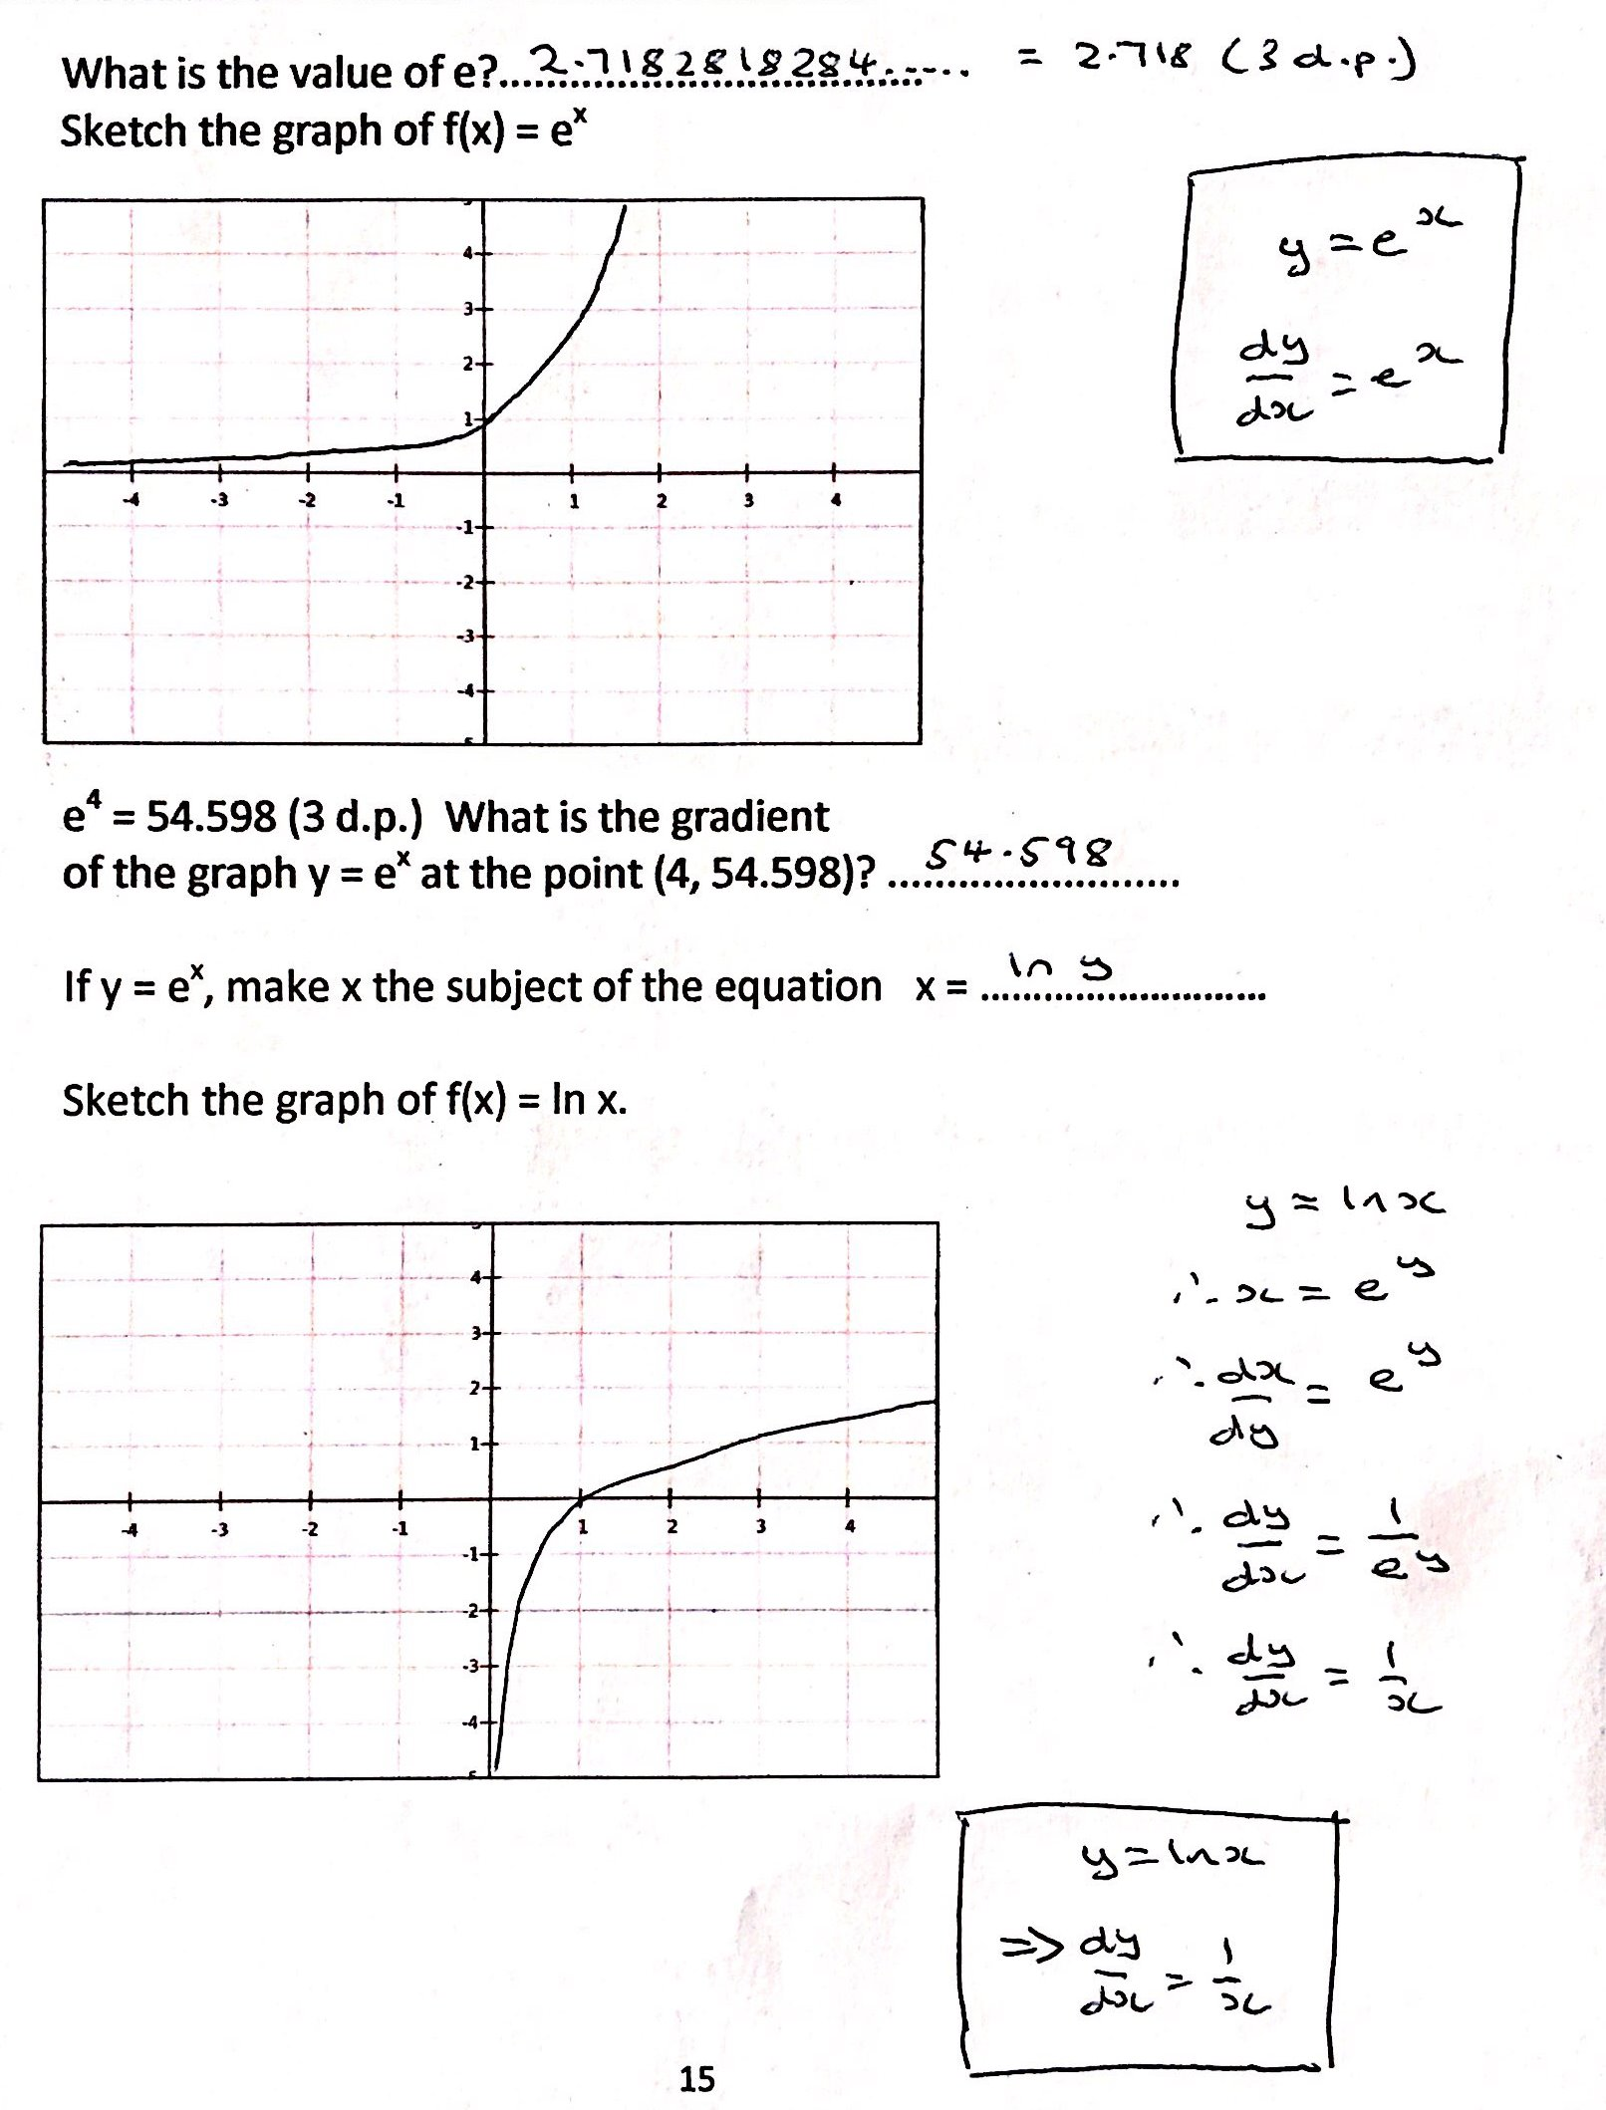

|  |  |
| --- | --- |
| **C4: Integration as the inverse of differentiation** | |
| <https://youtu.be/NRZJw-FtuSA> | C:\Users\Mick and Roo\AppData\Local\Microsoft\Windows\Temporary Internet Files\Content.IE5\0CQVB242\qrcode.29723137.png |

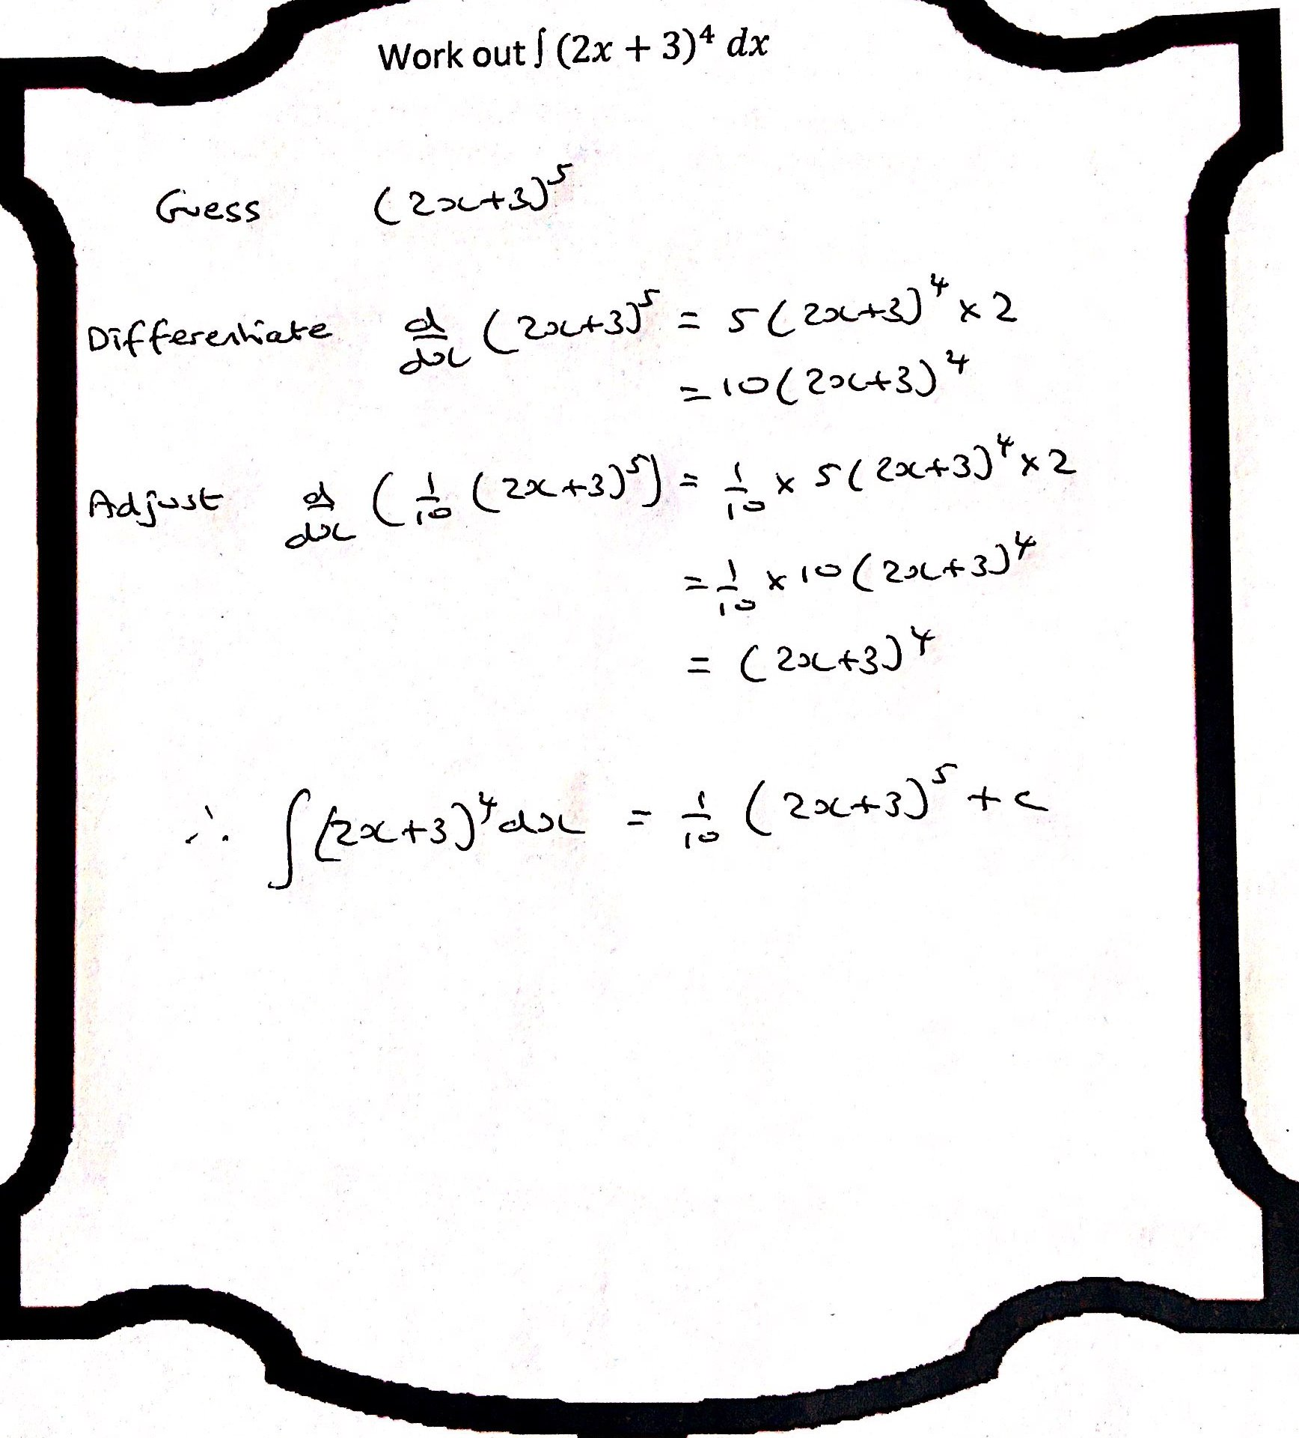

|  |  |
| --- | --- |
| **C3: Revision for Continuing With Confidence Test 1**  **Simplifying Algebraic Fractions** | |
| https://youtu.be/PY1lwgBLnqo | C:\Users\Mick and Roo\AppData\Local\Microsoft\Windows\INetCache\IE\S2NBW54N\qrcode.41227739.png |

Express ** – ** as a single fraction in its simplest form.

[](https://www.google.co.uk/url?sa=i&rct=j&q=&esrc=s&source=images&cd=&cad=rja&uact=8&ved=0ahUKEwjTwK2D-PvVAhVOIlAKHe-lDnoQjRwIBw&url=https://ebtionko.wordpress.com/2013/04/23/50-math-jokes/&psig=AFQjCNGXshZ3dJlvKaoRLeSzQtQhscabuQ&ust=1504078717927684)

|  |  |
| --- | --- |
| **C3: Revision for Continuing With Confidence Test 2**  **Differentiating ln** | |
| https://youtu.be/8uUqYRl9T0Q | C:\Users\Mick and Roo\AppData\Local\Microsoft\Windows\INetCache\IE\VMDRMU4Y\qrcode.41227861.png |

The point *P* lies on the curve with equation *y* = ln.The *x*-coordinate of *P* is 3.

Find an equation of the normal to the curve at the point *P* in the form *y* = *ax* + *b*, where *a* and *b* are constants.

[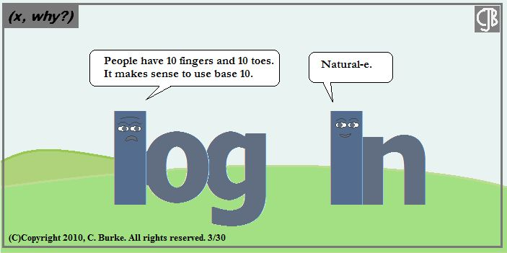](https://www.google.co.uk/url?sa=i&rct=j&q=&esrc=s&source=images&cd=&cad=rja&uact=8&ved=0ahUKEwitworu_vvVAhWPPFAKHe0kBH8QjRwIBw&url=https://dnichols30582.edublogs.org/advanced-algebra/&psig=AFQjCNEBFJVonWrXoxYPJqesacExbWNmSw&ust=1504080557084929)

|  |  |
| --- | --- |
| **C3: Revision for Continuing With Confidence Test 3**  **Product and Quotient Rule** | |
| https://youtu.be/X8xxaHJtsJE | C:\Users\Mick and Roo\AppData\Local\Microsoft\Windows\INetCache\IE\DK7FRESK\qrcode.41228020.png |

Differentiate with respect to *x*

(i) *x*2e3*x* + 2,

(ii) .

[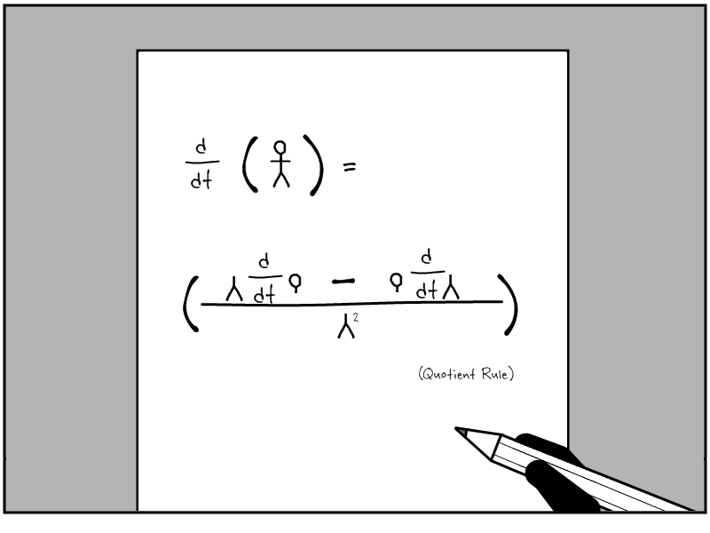](https://www.google.co.uk/url?sa=i&rct=j&q=&esrc=s&source=images&cd=&cad=rja&uact=8&ved=0ahUKEwjPitbI-PvVAhXBblAKHbsGC8UQjRwIBw&url=https://www.pinterest.com/karaklinke/calculus/&psig=AFQjCNFBGOk7B5T5EoRQhEoOPnOD0pl4Og&ust=1504078837783884)

|  |  |
| --- | --- |
| **C3: Revision for Continuing With Confidence Test 4**  **Trig proofs** | |
| <https://youtu.be/Csj_NSc1uOk> | C:\Users\Mick and Roo\AppData\Local\Microsoft\Windows\INetCache\IE\S2NBW54N\qrcode.41228069.png |

Show that

(i)  ≡ cos *x* – sin *x*, *x* ≠ (*n* – )*π*, *n* ∈ ℤ,

(ii) $\frac{1}{2}$ (cos 2*x* – sin 2*x*) ≡ cos2 *x* – cos *x* sin *x* – .

[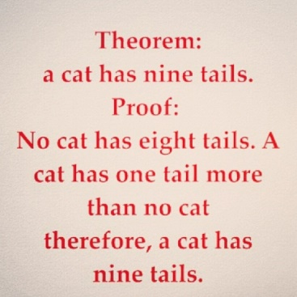](http://www.google.co.uk/url?sa=i&rct=j&q=&esrc=s&source=images&cd=&cad=rja&uact=8&ved=0ahUKEwi467rL_vvVAhUFKVAKHTtdBZAQjRwIBw&url=http://www.mathfunny.com/tag/proof/page/2/&psig=AFQjCNE5eOpXPWlyb25lMi3j7lqm5mKN1g&ust=1504080469840042)

|  |  |
| --- | --- |
| **C3: Functions – Domain, Range, Composite** | |
| <https://youtu.be/obyZwc7EX3Y> | C:\Users\Mick and Roo\AppData\Local\Microsoft\Windows\Temporary Internet Files\Content.IE5\KFCF9TXG\qrcode.29730890.png |

***Define these terms***

A mapping………………………………………………………………………………………………………………………………………………………

……………………………………………………………………………………………………………………………………………………………………

Domain………………………………………………………………………………………………………………………………………………………

……………………………………………………………………………………………………………………………………………………………………

Range…………………………………………………………………………………………………………………………………………………………

……………………………………………………………………………………………………………………………………………………………………

Function………………………………………………………………………………………………………………………………………………………

……………………………………………………………………………………………………………………………………………………………………

[](http://www.google.co.uk/url?sa=i&rct=j&q=&esrc=s&source=images&cd=&cad=rja&uact=8&ved=0CAcQjRw&url=http://en.wikipedia.org/wiki/Real_number&ei=SAFkVePpNsK9UZeygYgD&bvm=bv.93990622,d.d24&psig=AFQjCNF-KWV2eLGJEDpJ-hHAQsDPOtYpsA&ust=1432703685239085)…………………………………………………………………………………………………………………………………………………………………

……………………………………………………………………………………………………………………………………………………………………

Composite Function……………………………………………………………………………………………………………………………………

……………………………………………………………………………………………………………………………………………………………………

If f(x) = 3x +2 and g(x) = $x^{2}+1$,

1. what is fg (x)
2. what is gf (x)

|  |  |
| --- | --- |
| **C3 Functions – Modulus, Inverse, Transformations** | |
| <https://youtu.be/dxzM3Yl0X5s> | C:\Users\Mick and Roo\AppData\Local\Microsoft\Windows\Temporary Internet Files\Content.IE5\CNSJ7SJI\qrcode.29730979.png |

If f(x) = 3x + 2, what is f-1(x) ? Show the full working.

Sketch the following functions

f(x) = |3x + 2| f(x) = |x| - 2

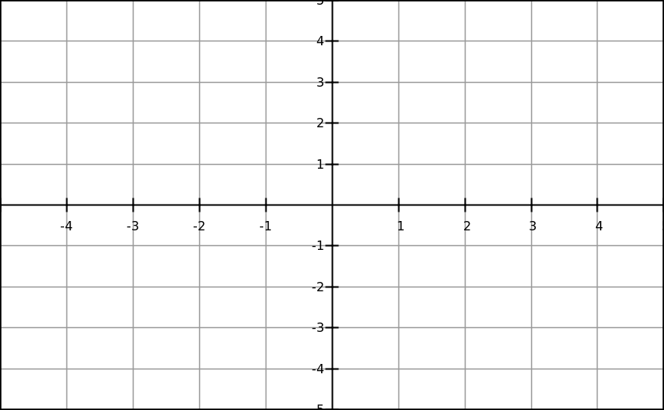

The graph shows the function f(x)

Sketch the graphs of

y = |f(x)| y = f(|x|)

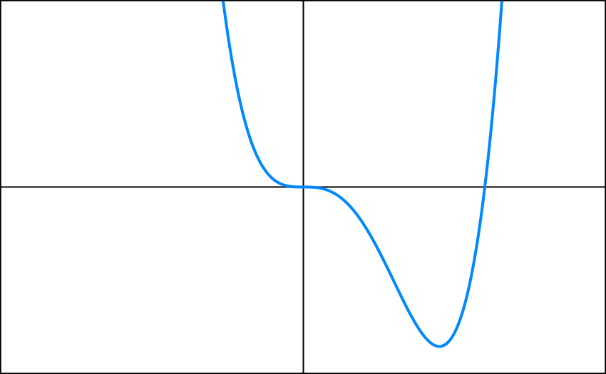

|  |  |
| --- | --- |
| **C3: Numerical Methods** | |
| <https://youtu.be/4JYb-lPtspU> | C:\Users\Mick and Roo\AppData\Local\Microsoft\Windows\Temporary Internet Files\Content.IE5\4GOYBCPB\qrcode.29740809.png |



Show that there is a root of the equation $ln x$ = $\frac{1}{x}$ between x = 1.7 and x = 1.8.

Underline the key sentence that you must write at the end of these questions.

Use iteration to find a solution to x2 – 4x + 1 = 0 correct to 2 d.p.

|  |  |
| --- | --- |
| **C3: R cos (x + α)** | |
| Use <https://youtu.be/dmrFYuNfkFg>  http://www.wpclipart.com/education/supplies/paper/paper_2/spiral_notebook_paper_page.jpg | C:\Users\Mick and Roo\AppData\Local\Microsoft\Windows\Temporary Internet Files\Content.IE5\4GOYBCPB\qrcode.29728994.png |

Solve the equation 3 cos x + 5 sin x = 2

(0° ≤ x ≤ 360°)

Show the full working.

|  |  |
| --- | --- |
| **C3: Inverse trig functions including graphs** | |
| <https://youtu.be/hklOnHJx1t4> | C:\Users\Mick and Roo\AppData\Local\Microsoft\Windows\Temporary Internet Files\Content.IE5\0CQVB242\qrcode.29740751.png |

What is the difference between y = sin-1x and y = (sin x )-1 ?

…………………………………………………………………………………………………………………………

Sketch the graphs of

y = arc sin x (y = sin-1x) y = arc cos x (y = cos-1x)

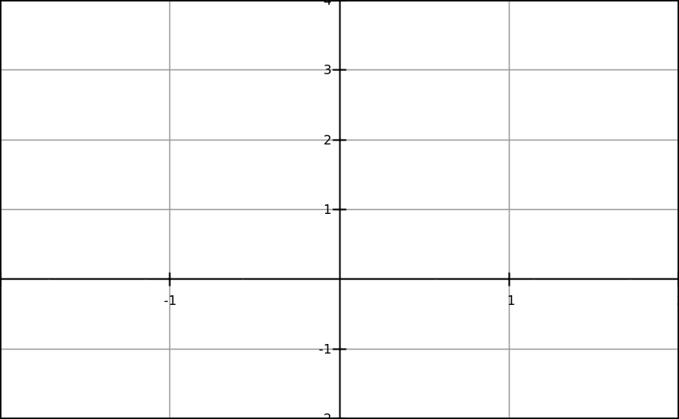

y = arc tan x (y = tan-1x)

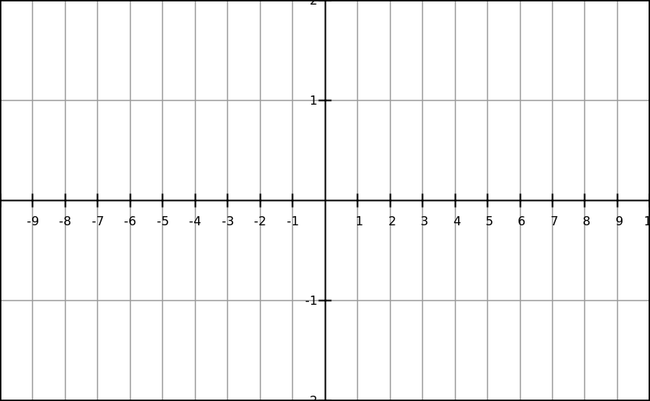

|  |  |
| --- | --- |
| **C3: dy/dx = 1/ (dx/dy)** | |
| <https://youtu.be/KEoip8FNAp4>  http://i.stack.imgur.com/rpi0a.png | C:\Users\Mick and Roo\AppData\Local\Microsoft\Windows\Temporary Internet Files\Content.IE5\CNSJ7SJI\qrcode.29723143.png |

Find the value of $\frac{dy}{dx}$ at the point (2,1) on the curve with

equation $y^{3}+y=x$

|  |  |
| --- | --- |
| **C4: Implicit Differentiation** | |
| <https://youtu.be/am9WPDZL76M> | C:\Users\Mick and Roo\AppData\Local\Microsoft\Windows\Temporary Internet Files\Content.IE5\Y68R8Z02\qrcode.29748009.png |



The equation of a curve is $3x^{3}+2x^{2}y^{3}+4y^{7}=12$

Find an expression for $\frac{dy}{dx}$

|  |  |
| --- | --- |
| **C4: Binomial Expansion** | |
| <https://youtu.be/eC2I1eismWQ> | C:\Users\Mick and Roo\AppData\Local\Microsoft\Windows\Temporary Internet Files\Content.IE5\CNSJ7SJI\qrcode.29951598.png |



What is the binomial expansion which is valid for all values of n?

If n is fractional or negative, the expansion is only valid for certain values of x. What are those values?

|  |  |
| --- | --- |
| **C4 Partial Fractions** | |
| <https://youtu.be/OeUCqui7bu0>  http://content.mycutegraphics.com/borders/loopy-border.png | C:\Users\Mick and Roo\AppData\Local\Microsoft\Windows\Temporary Internet Files\Content.IE5\QUEJYM1X\qrcode.29740893.png |

Write in partial fractions. Show the full method

Write $\frac{11x^{2}+14x +5}{{\left(x+1\right)}^{2}\left(2x+1\right)}$ in partial fractions. Show the full method



….continued on next page

|  |
| --- |
| **C4 Partial Fractions Page 2** |

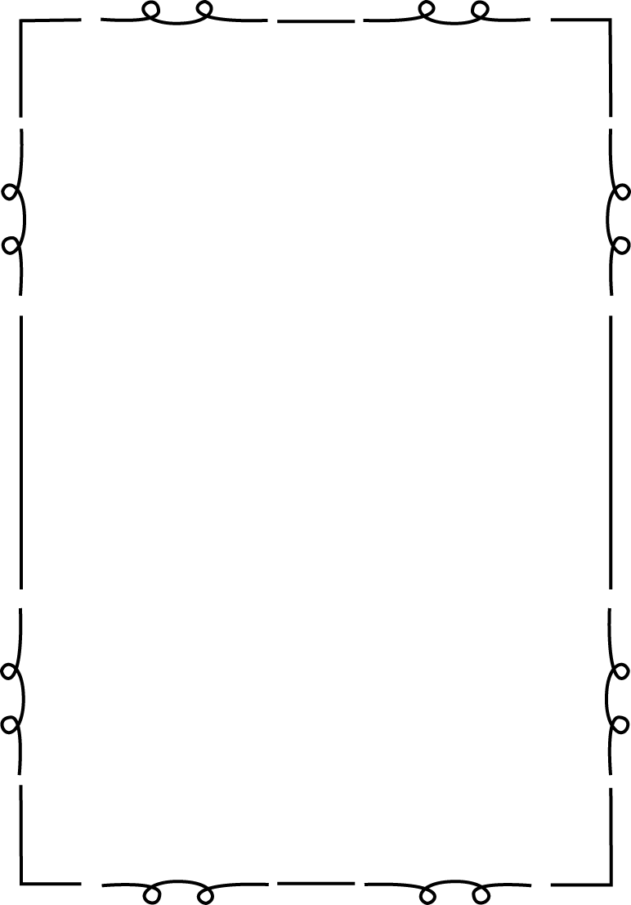

Write $\frac{3x^{2}-3x-2}{\left(x-1\right)\left(x-2\right)}$ in partial fractions. Show the full method

|  |  |
| --- | --- |
| **C4: Integration (Trig, Partial Fractions, ln x)** | |
| <https://youtu.be/wHYbo3igKqs> | C:\Users\Mick and Roo\AppData\Local\Microsoft\Windows\Temporary Internet Files\Content.IE5\4GOYBCPB\qrcode.29747034.png |



Show how to integrate the following

∫ $\tan^{2}{x dx}$

∫ $\sin^{2}{x dx}$

∫ $\cos^{2}{x dx}$

**

….continued on the next page

** This isn’t on the video. We shall do this in the lesson

|  |
| --- |
| **C4: Integration (Trig, Partial Fractions, ln x) page 2** |



∫ $\frac{f^{'}\left(x\right)}{f\left(x\right)}$ dx =

∫ $\frac{x-5}{\left(x+1\right)\left(x-2\right)}$ dx

|  |  |
| --- | --- |
| **C4: Trapezium Rule and Percentage Error** | |
| <https://youtu.be/IBMPn_4eKqY> | C:\Users\Mick and Roo\AppData\Local\Microsoft\Windows\Temporary Internet Files\Content.IE5\5YRM7R83\qrcode.29913990.png |



Use the trapezium rule with 4 strips to find an approximate value for $\int_{0}^{\frac{π}{3}}{\sec{x dx}}$

When calculating the percentage error, use this formula

Percentage error =

|  |  |
| --- | --- |
| **C4: Integration by Parts** | |
| <https://youtu.be/3ElTLQirl4E>  http://content.mycutegraphics.com/borders/squiggle-border.png | C:\Users\Mick and Roo\AppData\Local\Microsoft\Windows\Temporary Internet Files\Content.IE5\5YRM7R83\qrcode.29925880.png |

The formula for integration by parts is

$$u\frac{dv}{dx} dx=$$

Use integration by parts to work out ∫ x cos x dx

|  |  |
| --- | --- |
| **C4: Integration by Substitution** | |
| <https://youtu.be/WeAKe8uGQ1M>  http://www.clipartbest.com/cliparts/jix/pEy/jixpEy85T.gif | C:\Users\Mick and Roo\AppData\Local\Microsoft\Windows\Temporary Internet Files\Content.IE5\KFCF9TXG\qrcode.29926268.png |

Use integration by substitution to work out

∫ x √(2x + 5) dx

Use integration by substitution to evaluate

$\int_{0}^{\frac{π}{2}}{\cos{x √(1+\sin{x) dx}}}$

|  |  |
| --- | --- |
| **C4: Connected rates of Change** | |
| <https://youtu.be/OyeiYysYXZI> | C:\Users\Mick and Roo\AppData\Local\Microsoft\Windows\Temporary Internet Files\Content.IE5\0CQVB242\qrcode.29951656.png |

The rate of change of the radius of a circle is 5 cm s-1. Find the rate of change of the area of the circle when the radius is 3 cm.

|  |  |
| --- | --- |
| **C4: Vectors - Introduction** | |
| <https://youtu.be/2OWPNzC7JBI>  http://www.diversafitness.com/images/notepad.jpg | C:\Users\Mick and Roo\AppData\Local\Microsoft\Windows\Temporary Internet Files\Content.IE5\5YRM7R83\qrcode.29914972.png |

The first part of this video is revision of GCSE vectors. Make your own notes of stuff you may have forgotten.

Find a unit vector which is in the direction 3**a** + 4**b**

What are the vectors **i**, **j** and **k**?

Find the distance between (4,3,6) and (3,4,-2)

|  |  |
| --- | --- |
| **C4: Vectors – scalar (dot) product** | |
| <https://youtu.be/zkAMAhqeXio> | C:\Users\Mick and Roo\AppData\Local\Microsoft\Windows\Temporary Internet Files\Content.IE5\0CQVB242\qrcode.29915942.png |

What is the definition of **a**.**b** ?

If **a**= a1**i** + a2**j** + a3**k** and **b** = b1**i** + b2**j** + b3**k** what is **a**.**b** ?

What is the angle between $\left({4 \atop \begin{aligned}-2 \\ 3\end{aligned}}\right)$ and $\left({2 \atop \begin{aligned}1 \\ -6\end{aligned}}\right)$?

|  |  |
| --- | --- |
| **C4: Vectors – vector equation of a line** | |
| <https://youtu.be/ltVa0nqX7o8>  http://www.kidsmathgamesonline.com/images/pictures/shapes/rectangle.jpg | C:\Users\Mick and Roo\AppData\Local\Microsoft\Windows\Temporary Internet Files\Content.IE5\4GOYBCPB\qrcode.29924360.png |

A straight line passes through (-1,1) and (0,1). What is the vector equation of this line?

This next bit isn’t in the video. Try to write down the answer. We will discuss in the lesson.

The vector equation of a straight line is **r** = **a** + λ**b**.

What information is given by a?

What information is given by b?

|  |  |
| --- | --- |
| **C4: Forming Differential Equations** | |
| <https://youtu.be/dnWa5_3eNb8>  http://content.mycutegraphics.com/borders/striped-double-border.png | C:\Users\Mick and Roo\AppData\Local\Microsoft\Windows\Temporary Internet Files\Content.IE5\0CQVB242\qrcode.29740984.png |



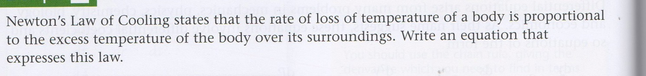

|  |  |
| --- | --- |
| **C4: Differential Equations** | |
| <https://youtu.be/q9a52OxY3Ww>  http://2.bp.blogspot.com/-yVFEanCWF-g/UTREDQ8uFUI/AAAAAAAAFF0/FvRIMn4s0Bs/s1600/np1.png | C:\Users\Mick and Roo\AppData\Local\Microsoft\Windows\Temporary Internet Files\Content.IE5\5YRM7R83\qrcode.29951642.png |

Solve the differential equation $\frac{dy}{dx}=x\cos{y}$. Use the boundary condition that y=0 when x = 1

|  |  |
| --- | --- |
| **C4: Parametrics** | |
| <https://youtu.be/nFClKAxutOc>  http://content.mycutegraphics.com/borders/striped-double-border.png | C:\Users\Mick and Roo\AppData\Local\Microsoft\Windows\Temporary Internet Files\Content.IE5\Y68R8Z02\qrcode.29951612.png |

A curve is defined by the parametric equations x=2t and y = t2.

What is the Cartesian equation of this curve?

A curve is defined by the parametric equations x=t2 and y = 2t(3-t). Find the area between this curve and the x axis which is bounded by the y-axis and the line x= 3

|  |  |
| --- | --- |
| **C4: Volumes of Solids of Revolution** | |
| <https://youtu.be/djcBiBMwI7Q> | C:\Users\Mick and Roo\AppData\Local\Microsoft\Windows\Temporary Internet Files\Content.IE5\4GOYBCPB\qrcode.29951555.png |



What is the formula for the volume of a solid of revolution?

What is the formula for the area under a curve?

**Unit C3: Core Mathematics 3**

This section lists formulae that candidates are expected to remember and that may not be included in formulae booklets.

**Trigonometry**



**Differentiation**

|  |  |  |
| --- | --- | --- |
| **function** | | **Derivative** |
|  | |  |
| sin *kx* | | *k* cos *kx* |
| cos *kx* | | –*k* sin *kx* |
| e*kx* | | *k*e*kx* |
| ln *x* | |  |
| f (*x*) + g (*x*) | |  |
|  | |  |
| f (g (*x*)) | |  |
|  | |  | | |

**C3 Syllabus**

**1 Algebra and functions**

|  |  |
| --- | --- |
| Simplification of rational expressions including factorising and cancelling, and algebraic division. | Denominators of rational expressions will be linear or quadratic, eg , , . |
| Definition of a function. Domain and range of functions. Composition of functions. Inverse functions and their graphs. | The concept of a function as a one-one or many-one mapping from ℝ (or a subset of ℝ) to ℝ. The notation  f : *x*  and f(*x*) will be used.  Candidates should know that fg will mean ‘do g first, then f ’.  Candidates should know that if f −1 exists, then f −1f(*x*) = ff −1(*x*) = *x*. |
| The modulus function. | Candidates should be able to sketch the graphs of *y* = ⏐*ax* + *b*⏐ and the graphs of *y =* ⏐f(*x*)⏐ and *y* = f(⏐*x*⏐), given the graph of *y*= f(*x*). |
| Combinations of the transformations *y* = f(*x*) as represented by *y*= *a*f(*x*), *y* = f(*x*) + *a*, *y* = f(*x* + *a*), *y*= f(*ax*). | Candidates should be able to sketch the graph of, for example, *y* = 2f(3*x*), *y* = f(−*x*) + 1, given the graph of *y*= f(*x*) or the graph of, for example, *y*= 3 + sin 2*x*, *y* = −cos .  The graph of *y* = f(*ax* + *b*) will *not* be required. |

**2 Trigonometry**

|  |  |  |
| --- | --- | --- |
| Knowledge of secant, cosecant and cotangent and of arcsin, arccos and arctan. Their relationships to sine, cosine and tangent. Understanding of their graphs and appropriate restricted domains. | Angles measured in both degrees and radians. | |
| Knowledge and use of sec2 *θ* = 1 + tan2 *θ* and cosec2 *θ* = 1 + cot2 *θ*. |  | |
| Knowledge and use of double angle formulae; use of formulae for sin(*A* ± *B*), cos (*A* ± *B*) and tan (*A* ± *B*) and of expressions for *a*cos *θ + b*sin *θ* in the equivalent forms of *r*cos (*θ*± *a*) or *r*sin (*θ*± *a*). | | To include application to half angles. Knowledge of the *t* (tan ) formulae will *not* be required.  Candidates should be able to solve equations such as *a* cos *θ* + *b* sin *θ*  = *c* in a given interval, and to prove simple identities such as  cos *x*cos 2*x* + sin *x* sin 2*x* ≡ cos *x*. | |

**3 Exponentials and logarithms**

|  |  |
| --- | --- |
| The function e*x* and its graph. | To include the graph of *y* = e*ax* + *b* + *c*. |
| The function ln *x* and its graph; ln *x* as the inverse function of e*x*. | Solution of equations of the form  e*ax*+*b*= *p* and ln (a*x*+ *b*) = *q* is expected. |

**4 Differentiation**

|  |  |
| --- | --- |
| Differentiation ofe*x*, ln *x*, sin *x,* cos *x,* tan *x* and their sums and differences*.* |  |
| Differentiation using the product rule, the quotient rule and the chain rule. | Differentiation of cosec *x*, cot *x* and sec *x* are required. Skill will be expected in the differentiation of functions generated from standard forms using products, quotients and composition, such as 2*x*4 sin *x*, , cos *x*2 and tan2 2*x*. |
| The use of. | E.g. finding  for *x* = sin 3*y*. |

**5 Numerical methods**

|  |  |
| --- | --- |
| Location of roots of f(*x*) = 0 by consideringchanges of sign of f(*x*) in an interval of xin which f(*x*) is continuous. |  |
| Approximate solution of equations using simple iterative methods, including recurrence relations of the form *xn*+1 = f(*xn*)*.* | Solution of equations by use of iterative procedures for which leads will be given. |

**Unit C4: Core Mathematics 4**

This section lists formulae that candidates are expected to remember and that may not be included in formulae booklets.

**Integration**

|  |  |
| --- | --- |
| **function** | **integral** |
|  |  |
| cos *kx* | + *c* |
| sin *kx* | + *c* |
| e*kx* | + *c* |
|  | + *c,* |
|  | + *c* |
|  | + *c* |

**Vectors**



|  |  |
| --- | --- |
|  |  |
|  |

**C4 Syllabus**

**1 Algebra and functions**

|  |  |
| --- | --- |
| Rational functions. Partial fractions (denominators not more complicated than repeated linear terms). | Partial fractions to include denominators such as  (*ax* + *b*)(*cx* + *d*)(*ex* + *f*)  and (*ax* + *b*)(*cx* + *d*)2.  The degree of the numerator may equal or exceed the degree of the denominator. Applications to integration, differentiation and series expansions.  Quadratic factors in the denominator such as (*x*2 + *a*), *a* > 0, are *not* required. |

**2 Coordinate geometry in the (*x*, *y*) plane**

|  |  |
| --- | --- |
| Parametric equations of curves and conversion between Cartesian and parametric forms. | Candidates should be able to find the area under a curve given its parametric equations. Candidates will *not* be expected to sketch a curve from its parametric equations. |

**3 Sequences and series**

|  |  |
| --- | --- |
| Binomial series for any rational *n*. | For, candidates should be able to obtain the expansion of (*ax* + *b*)*n*, and the expansion of rational functions by decomposition into partial fractions. |

**4 Differentiation**

|  |  |
| --- | --- |
| Differentiation of simple functions defined implicitly or  parametrically. | The finding of equations of tangents and normals to curves given parametrically or implicitly is required. |
| Exponential growth and decay. | Knowledge and use of the result  (*ax*) = *ax* ln *a* is expected. |
| Formation of simple differential equations. | Questions involving connected rates of change may be set. |

**5 Integration**

|  |  |
| --- | --- |
| Integration of e*x*, *,* sin*x,* cos*x*. | To include integration of standard functions such as sin 3*x*, sec2 2*x*, tan *x*, e5*x*, .  Candidates should recognise integrals of the form  = ln f(*x*) + *c*.  Candidates are expected to be able to use trigonometric identities to integrate, for example, sin2 *x*, tan2 *x*, cos2 3*x.* |
| Evaluation of volume of revolution. | is required, but *not* . Candidates should be able to find a volume of revolution, given parametric equations. |
| Simple cases of integration by substitution and integration by parts. These methods as the reverse processes of the chain and product rules respectively. | Except in the simplest of cases the substitution will be given.  The integral d*x* is required.  More than one application of integration by parts may be required, for example . |
| Simple cases of integration using partial fractions. | Integration of rational expressions such as those arising from partial fractions, e.g. , .  Note that the integration of other rational expressions, such as  and  is also required (see above paragraphs). |
| Analytical solution of simple first order differential equations with separable variables. | General and particular solutions will be required. |
| Numerical integration of functions. | Application of the trapezium rule to functions covered in C3 and C4. Use of increasing number of trapezia to improve accuracy and estimate error will be required. Questions will not require more than three iterations. |
|  | Simpson’s Rule is *not* required. |

**6 Vectors**

|  |  |
| --- | --- |
| Vectors in two and three dimensions. |  |
| Magnitude of a vector. | Candidates should be able to find a unit vector in the direction of **a**, and be familiar with ⏐*a*⏐. |
| Algebraic operations of vector addition and multiplication by scalars, and their geometrical interpretations. |  |
| Position vectors.  The distance between two points. | .  The distance *d* between two points  (*x*1 , *y*1 , *z*1) and (*x*2 , *y*2 , *z*2) is given by  *d* 2 = (*x*1 – *x*2)2 + (*y*1 – *y*2)2 + (*z*1 – *z*2)2 . |
| Vector equations of lines. | To include the forms **r** = **a** + *t***b** and  **r** = **c** + *t*(**d** – **c**).  Intersection ,or otherwise, of two lines. |
| The scalar product. Its use for calculating the angle between two lines. | Candidates should know that for  **= a** = *a*1**i** + *a*2**j** + *a*3**k** and  = **b** = *b*1**i** + *b*2**j** + *b*3**k** then  **a . b** = *a*1*b*1 + *a*2*b*2 + *a*3*b*3 and  cos ∠*AOB* =  .  Candidates should know that if **a . b**= 0, and that **a**and **b** are non-zero vectors, then **a** and **b** are perpendicular. |

**Formulae and Tables**

**Core Mathematics C3**

**Logarithms and exponentials**



**Trigonometric identities**















**Differentiation**

|  |  |
| --- | --- |
| **f(*x*)** | **f ′(*x*)** |
| tan *kx* | *k* sec2 *kx* |
| sec *x* | sec *x* tan *x* |
| cot *x* | –cosec2 *x* |
| cosec *x* | –cosec *x* cot *x* |
|  |  |

**Core Mathematics C4**

***Integration* (+ *constant*)**

|  |  |
| --- | --- |
| **f(*x*)** |  |
| sec2 *kx* | tan *kx* |
|  |  |
|  |  |
|  |  |
|  |  |

